Data Fundamentals for AI

Learn About Data and AI
Learning Objectives
After completing this unit, you’ll be able to:
- Understand the concept of data and its importance in the modern world.
- Explain the role of data-driven decision-making in modern organizations and how it differs from traditional decision-making.
- Define AI and articulate its significance in today’s world.
Trailcast
If you'd like to listen to an audio recording of this module, please use the player below. When you’re finished listening to this recording, remember to come back to each unit, check out the resources, and complete the associated assessments.

This module was produced in collaboration with OneNine AI. Learn about partner content on Trailhead (log in required).
The Importance of Data
Data is a collection of facts, figures, statistics, documents, images, videos, and anything else that provides insight into various aspects of the world. Today, data is an essential component of modern life and the economy. With the rise of technology, businesses can collect, store, and analyze vast amounts of data to gain insights into their operations and customers.
Data can be considered the most valuable asset in the modern world and is collected in many forms.

Data provides valuable insights and information that can help individuals and organizations make better decisions. It’s now generated at an unprecedented rate. And businesses and governments are using data to gain insights into consumer behavior, market trends, and other important factors.
Here are industry-specific examples of how data impacts our world.
Industry | Outcome
Business and Finance | By analyzing data, businesses can identify new opportunities and develop new products and services that meet their customers’ needs.
Healthcare and Medicine | By analyzing data, researchers can identify patterns and correlations that can lead to breakthrough discoveries. Data plays a crucial role in developing new treatments and cures for diseases.
Other | Data can be used in almost any industry to improve operations and drive business success.
Data-Driven Decision-Making
Data-driven decision-making is a process of making decisions based on data analysis rather than intuition or personal experience. In modern organizations, data-driven decision-making is increasingly important due to the large amounts of data available. Data-driven decision-making can provide more accurate and reliable insights into business operations, customer behavior, and market trends.
Traditional decision-making, on the other hand, relies on intuition, personal experience, and other subjective factors. While traditional decision-making can be effective in some situations, it can lead to biased decisions and missed opportunities.
To implement data-driven decision-making, organizations must collect, store, and analyze data effectively. This requires the use of various tools and techniques, such as data visualization, statistical analysis, and machine learning (ML).
Here are key benefits and outcomes that sum up the role of data-driven decision-making in modern organizations.
Key Benefit | Outcome
Provides insights | By analyzing data, organizations can identify patterns and correlations that may not be apparent through other means, leading to more-informed decisions.
Improves performance | Data-driven decision-making can lead to improved performance by identifying areas where organizations can reduce costs, improve efficiency, and optimize operations.
Increases competitiveness | By using data to gain insights into customer behavior and market trends, organizations can develop products and services that better serve their customers’ needs.
The Significance of AI
Artificial intelligence (AI) is a branch of computer science in which computer systems use data to draw inferences, perform tasks, and solve problems with human-like reasoning. AI is important in today’s world due to its ability to automate various tasks, improve efficiency, and reduce costs. AI is used in various industries, including healthcare, finance, transportation, and manufacturing to improve operations and provide better services to customers.
Data is essential in enabling AI to learn and perform work that would normally require human intelligence, and to provide insights that improve operations and services across industries. In healthcare, AI requires large datasets of medical images and patient data to analyze and identify health risks. In finance, AI analyzes large amounts of financial data to make investment decisions and detect fraudulent activity. In manufacturing, AI uses sensor and production data to monitor equipment performance, identify maintenance issues, and optimize production processes.
Here are some of the key applications of AI across industries.
- Healthcare: In the healthcare industry, AI is used for medical imaging, drug discovery, and patient monitoring. AI-powered medical imaging can help physicians detect diseases and injuries more accurately, while AI-powered drug discovery can help researchers develop new drugs more quickly. AI can also be used to monitor patients’ conditions in real time, enabling healthcare providers to deliver personalized care more effectively.
- Finance: In the finance industry, AI is used for fraud detection, credit scoring, and investment management. AI-powered fraud detection can help banks and other financial institutions identify fraudulent transactions more quickly and accurately, while AI-powered credit scoring can provide more accurate assessments of creditworthiness. AI can also be used to manage investments, enabling financial advisors to make more informed decisions.
- Manufacturing: In the manufacturing industry, AI is used for quality control, predictive maintenance, and supply chain optimization. AI-powered quality control can help manufacturers identify defects and improve product quality, while AI-powered predictive maintenance can reduce downtime and improve efficiency. AI can also be used to optimize supply chains, enabling manufacturers to deliver products more efficiently.
AI has become an essential technology in various industries due to its ability to automate tasks, improve efficiency, and reduce costs. By using AI, businesses can improve their operations and provide better services to customers, ultimately leading to increased competitiveness and better outcomes for all.
In this unit, you learned about the importance of data and its role in data-driven decision-making. You also discovered the basics of AI and its various applications across different industries. In the next unit, you dive deeper into data concepts, including data types, data cleaning, and data sources.
Resources
- GitHub: Data Literacy
- GitHub: Data Analysis Introduction
- Tableau Site: The Cycle of Visual Analysis
- GitHub: Types of Data Visualisations
- External Site: Data literacy for leaders
- Tableau Site: Grow Your Data and AI Skills
- Trailhead: Build Your Data Literacy Trail
- Salesforce Blog: The Definitive Data Glossary for Business Leaders

Understand Data and Its Significance
Learning Objectives
After completing this unit, you’ll be able to:
- Explain types of data and formats, such as tabular, text, images, audios, and videos.
- Use techniques to identify types of data sources and data collection methods.
- Understand the impact of bad data on decision-making.
Trailcast
If you'd like to listen to an audio recording of this module, please use the player below. When you’re finished listening to this recording, remember to come back to each unit, check out the resources, and complete the associated assessments.
Data Classification and Types
With data being an essential component of industries today, it’s important to understand the different types of data, data sources and collection methods, and the importance of data in AI.
Data Classification
Data can be classified into three main categories: structured, unstructured, and semi-structured.
- Structured data is organized and formatted in a specific way. It has a well-defined format and is easily searchable and analyzable. Examples of structured data include spreadsheets and databases.
- Unstructured data, on the other hand, is not formatted in a specific way and can include text, documents, images, audio recordings, and videos. Unstructured data is more difficult to analyze, but it can provide valuable insights into customer behavior and market trends. Examples of unstructured data include social media posts, customer reviews, and conversational data like email messages or Slack posts.
- Semi-structured data is a combination of structured and unstructured data. It has some defined structure, but it may also contain unstructured elements. Examples of semi-structured data include XML (Extensible Markup Language) or JSON (JavaScript Object Notation) files.
Data Format
Data can also be classified by its format.
- Tabular data is structured data that is organized in rows and columns, such as in a spreadsheet.
- Text data includes unstructured data in the form of text documents, such as emails or reports.
- Image data can include visual information in the form of a brand logo, charts, and infographics.
- Geospatial data refers to geographic coordinates and the shape of country maps, representing essential information about the Earth’s surface.
- Time-series data refers to data that can contain information over a period of time, for example, daily stock prices over the past year.
Types of Data
Another way to classify data is by its type, which can be quantitative or qualitative.
- Quantitative data is numerical and can be measured and analyzed statistically. Examples of quantitative data include sales figures, customer counts based on geographical location, and website traffic.
- Qualitative data, on the other hand, is non-numerical and includes text, images, and videos. In many cases, qualitative data can be more difficult to analyze, but it can provide valuable insights into customer preferences and opinions. Examples of qualitative data include customer reviews, social media posts, and survey responses.
Both quantitative and qualitative data are important in the field of data analytics across a wide range of industries. For more detail on this topic, check out the Variables and Field Types Trailhead module.
Understanding different data types and classifications is important for effective data analysis. By categorizing data into structured, unstructured, and semi-structured categories, and differentiating between quantitative and qualitative data, organizations can more effectively choose the right analysis approach for gaining insights from it. Exploring different formats, such as tabular, text, and images, makes data analysis and interpretation more effective.
Data Collection Methods
Identifying data sources is an important step in data analysis. Data can be obtained from various sources, including internal, external, and public datasets. Internal data sources include data that is generated within an organization, such as sales data and customer data. External data sources include data that is obtained from outside the organization, such as market research and social media data. Public datasets are freely available datasets that can be used for analysis and research.
Data collection, labeling, and cleaning are important steps in data analysis.
- Data collection is the process of gathering data from various sources.
- Data labeling is assigning tags or labels to data to make it more easily searchable and analyzable. This can include assigning categories to data, such as age groups or product categories.
- Data cleaning is the process of removing or correcting errors and inconsistencies in the data to improve its quality and accuracy. Data cleaning can include removing duplicate data, correcting spelling errors, and filling in missing data.
Various techniques can be used for collecting data, such as surveys, interviews, observation, and web scraping.
- Surveys collect data from a group of people using a set of questions. They can be conducted online or in-person, and are often used to collect data on customer preferences and opinions.
- Interviews collect data from individuals through one-on-one conversations. They can provide more detailed data than surveys, but they can also be time-consuming.
- Observation collects data by watching and listening to people or events. This can provide valuable data on customer behavior and product interactions.
- Web scraping collects data from websites using software tools. It can be used to collect data on competitors, market trends, and customer reviews.
Exploratory data analysis (EDA) is usually the first step in any data project. The goal of EDA is to learn about general patterns in data and understand the insights and key characteristics about it.
The Importance of Data in AI
Data is an essential component of AI, and the quality and validity of data are critical to the success of AI applications. Considerations for data quality and validity include ensuring that the data is current, accurate, complete, and representative of the population being studied. Data that is incomplete, out-of-date, or contains errors can have a significant impact on decision-making and AI, leading to inaccurate or biased results.
Data quality is important from the beginning of an AI project. Here are a few areas of consideration that highlight the importance of data and data quality in AI.
- Training and performance: The quality of the data used for training AI models directly impacts their performance. High-quality data ensures that the model learns accurate and representative patterns, leading to more reliable predictions and better decision-making.
- Accuracy and bias: Data quality is vital in mitigating bias within AI systems. Biased or inaccurate data can lead to biased outcomes, reinforcing existing inequalities or perpetuating unfair practices. By ensuring data quality, organizations can strive for fairness and minimize discriminatory outcomes.
- Generalization and robustness: AI models should be able to handle new and unfamiliar data effectively, and consistently perform well in different situations. High-quality data ensures that the model learns relevant and diverse patterns, enabling it to make accurate predictions and handle new situations effectively.
- Trust and transparency: Data quality is closely tied to the trustworthiness and transparency of AI systems. Stakeholders must have confidence in the data used and the processes involved. Transparent data practices, along with data quality assurance, help build trust and foster accountability.
- Data governance and compliance: Proper data quality measures are essential for maintaining data governance and compliance with regulatory requirements. Organizations must ensure that the data used in AI systems adheres to privacy, security, and legal standards.
To achieve high data quality in AI, a robust data lifecycle is needed with focus on data diversity, representativeness, and addressing potential biases. There are various stages in the data lifecycle, and data quality is important in all of the stages. The data lifecycle includes collection, storage, processing, analysis, sharing, retention and disposal. You get more detail on the data lifecycle in the next unit.
In this unit, you learned about different types of data, data sources and collection methods, and the importance of data in AI. Next, get the basics on machine learning and how it’s different from traditional programming. And learn about AI techniques and their applications in the real world.
Resources
- GitHub: Data Literacy
- External Site: Medium: How Important Is Data in Machine Learning?
- Trailhead: Data Quality Trail
- Trailhead: Variables and Field Types
- Trailhead: Well-Structured Data

Discover AI Techniques and Applications
Learning Objectives
After completing this unit, you’ll be able to:
- Identify practical use cases of AI.
- Identify the limitations of AI models and ChatGPT.
- Understand the data lifecycle for AI and the importance of data privacy and security in AI applications.
Trailcast
If you'd like to listen to an audio recording of this module, please use the player below. When you’re finished listening to this recording, remember to come back to each unit, check out the resources, and complete the associated assessments.
Artificial Intelligence Technologies
Artificial Intelligence is the expansive field of making machines learn and think like humans. And there are many technologies that encompass AI.
- Machine learning uses various mathematical algorithms to get insights from data and make predictions.
- Deep learning uses a specific type of algorithm called a neural network to find associations between a set of inputs and outputs. Deep learning becomes more effective and efficient as the amount of data increases.
- Natural language processing is a technology that enables machines to take human language as an input and perform actions accordingly.
- Large language models are advanced computer models designed to understand and generate humanlike text.
- Computer vision is technology that enables machines to interpret visual information.
- Robotics is a technology that enables machines to perform physical tasks.
Check out the Artificial Intelligence Fundamentals Trailhead module to learn more.
Machine learning (ML) can be classified into several types based on the learning approach and the nature of the problem being solved.
- Supervised learning: In this machine learning approach, a model learns from labeled data, making predictions based on patterns it finds. The model can then make predictions or classify new, unseen data based on the patterns it has learned during training.
- Unsupervised learning: Here, the model learns from unlabeled data, finding patterns and relationships without predefined outputs. The model learns to identify similarities, group similar data points, or find underlying hidden patterns in the dataset.
- Reinforcement learning: This type of learning involves an agent learning through trial and error, taking actions to maximize rewards received from an environment. Reinforcement learning is often used in scenarios where an optimal decision-making strategy needs to be learned through trial and error, such as in robotics, game playing, and autonomous systems. The agent explores different actions and learns from the consequences of its actions to optimize its decision-making process.
AutoML and No Code AI tools like OneNine AI and Salesforce AI have been introduced in recent years to automate the process of building an entire machine learning pipeline, with minimal human intervention.
The Role of Machine Learning
Machine learning is a subset of artificial intelligence that uses statistical algorithms to enable computers to learn from data, without being explicitly programmed. It uses algorithms to build models that can make predictions or decisions based on inputs.
Machine Learning vs Programming
In traditional programming, the programmer must have a clear understanding of the problem and the solution they’re trying to achieve. In machine learning, the algorithm learns from the data and generates its own rules or models to solve the problem.
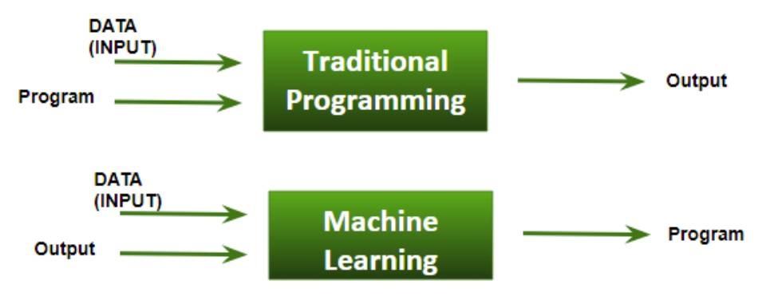
Importance of Data in Machine Learning
Data is the fuel driving machine learning. The quality and quantity of data used in training a machine learning model can have a significant impact on its accuracy and effectiveness. It’s essential to ensure that the data used is relevant, accurate, complete, and unbiased.
Data Quality and the Limitations of Machine Learning
To ensure data quality, it’s necessary to clean and preprocess the data, removing any noise (unwanted or meaningless information), missing values, or outliers.
While machine learning is a powerful tool for solving a wide range of problems, there are also limitations to its effectiveness including overfitting, underfitting, and bias.
- Overfitting occurs when the model is too complex and fits the training data too closely, resulting in poor generalization.
- Underfitting occurs when the model is too simple and does not capture the underlying patterns in the data.
- Bias occurs when the model is trained on data that is not representative of the real-world population.
Machine learning is limited by the quality and quantity of data used, lack of transparency in complex models, difficulty in generalizing to new situations, challenges with handling missing data, and potential for biased predictions.
While machine learning is a powerful tool, it’s important to be aware of these limitations and to consider them when designing and using machine learning models.
Predictive vs Generative AI
Predictive AI is the use of machine learning algorithms to make predictions or decisions based on data inputs. This can be used in a wide range of applications, including fraud detection, medical diagnosis, and customer churn prediction.
Distinct Approaches, Different Purposes
Predictive AI is a type of machine learning that trains a model to make predictions or decisions based on data. The model is given a set of input data and it learns to recognize patterns in the data that allow it to make accurate predictions for new inputs. Predictive AI is widely used in applications such as image recognition, speech recognition, and natural language processing.
Generative AI, on the other hand, creates new content, such as images, videos, or text, based on a given input. Rather than making predictions based on existing data, generative AI creates new data that is similar to the input data. This can be used in a wide range of applications, including art, music, and creative writing. One common example of generative AI is the use of neural networks to generate new images based on a given set of inputs.
While predictive and generative AI are different approaches to artificial intelligence, they’re not mutually exclusive. In fact, many AI applications use both predictive and generative techniques to achieve their goals. For example, a chatbot might use predictive AI to understand a user’s input, and generative AI to generate a response that is similar to human speech. Overall, the choice of predictive or generative AI depends on the specific application and project goals.
Now you know a thing or two about predictive AI and generative AI and their differences. For your reference, here’s a quick rundown of what each can do.
Predictive AI | Generative AI
Can make accurate predictions based on labeled data | Can generate new and creative content
Can be used to solve a wide range of problems, including fraud detection, medical diagnosis, and customer churn prediction | Can be used in a wide range of creative applications, such as art, music, and writing
Limited by the quality and quantity of labeled data available | Can generate biased or inappropriate content based on the input data
May struggle with making predictions outside of the labeled data it was trained on | May struggle with understanding context or generating coherent content
May require significant computational resources to train and deploy | May not be suitable for all applications, such as those that require accuracy and precision
Limitations of Generative AI
Generative AI creates new content, such as images, videos, or text, based on a given input. ChatGPT, for example, is a generative AI tool that uses large language models to generate humanlike responses to text inputs. It works by training on large amounts of text data and learning to predict the next word in a sequence based on the previous words.
While ChatGPT can generate humanlike responses, it also has limitations—it may generate biased or inappropriate responses based on the data it was trained on. This is a common problem with machine learning models, as they can reflect the biases and limitations of the training data. For example, if the training data contains a lot of negative or offensive language, ChatGPT may generate responses that are similarly negative or offensive.
ChatGPT may also struggle with understanding user input context or generating coherent responses. ChatGPT is only as good as the data it’s trained on. If the training data is incomplete, biased, or otherwise flawed, the model may not be able to generate accurate or useful responses. This can be a significant limitation in applications where accuracy and relevance are important. Similar to other machine learning models, data plays a critical role, so if the data it’s trained on is bad, then ChatGPT will not be very useful.
The ChatGPT example demonstrates the critical role that data plays in using AI effectively.
Data Lifecycle for AI
The data lifecycle refers to the stages that data goes through, from its initial collection to its eventual deletion. The data life cycle for AI consists of a series of steps, including data collection, preprocessing, training, evaluation, and deployment. It’s important to ensure that the data used is relevant, accurate, complete, and unbiased, and that the models generated are effective and ethical.
The data lifecycle for AI is an ongoing process, as models need to be continuously updated and refined based on new data and feedback. It’s an iterative process that requires careful attention to detail and a commitment to ethical and effective AI. Developers and users of ML models should ensure that their models are effective, accurate, and ethical, and make a positive impact in the world. The data lifecycle is crucial to ensuring that data is collected, stored, and used responsibly and ethically.
These are the stages of the data lifecycle.
- Data collection: In this stage, data is collected from various sources, such as sensors, surveys, and online sources.
- Data storage: Once data is collected, it must be stored securely.
- Data processing: In this stage, data is processed to extract insights and patterns. This may include using machine learning algorithms or other data analysis techniques.
- Data use: Once the data has been processed, it can be used for its intended purpose, such as making decisions or informing policy.
- Data sharing: At times, it may be necessary to share data with other organizations or individuals.
- Data retention: Data retention refers to the length of time that data is kept.
- Data disposal: Once data is no longer needed, it needs to be disposed of securely. This may involve securely deleting digital data or destroying physical media.
While AI and ML have the potential to revolutionize many industries and solve complex problems, it’s important to be aware of their limitations and ethical considerations. Continue to the next unit, to learn about the importance of data ethics and privacy.
Resources
- External Site: OneNine AI: AI Use Cases by Industry
- GitHub: Types of Deep Learning Models
- Trailhead: Artificial Inteligence Fundamentals
- Blog Post: What are ChatGPT’s limits?

Know Data Ethics, Privacy, and Practical Implementation
Learning Objectives
After completing this unit, you’ll be able to:
- Define and explain the importance of ethical considerations related to data collection and analysis.
- Understand the ethical issues related to ensuring data privacy, consent, and confidentiality.
- Understand different ways to protect data and the legal and regulatory frameworks for data protection, including GDPR, CCPA, and other relevant laws and regulations.
Trailcast
If you'd like to listen to an audio recording of this module, please use the player below. When you’re finished listening to this recording, remember to come back to each unit, check out the resources, and complete the associated assessments.
Ethics, Data, and AI
Data collection and analysis are critical components of AI and machine learning, but they can also raise ethical concerns. As data becomes increasingly valuable and accessible, it’s important to consider the ethical implications of how it’s collected, analyzed, and used.
Some examples of ethical issues in data collection and analysis include:
- Privacy violations: Collecting and analyzing personal information without consent, or using personal information for purposes other than those for which it was collected.
- Data breaches: Unauthorized access to or release of sensitive data, which can result in financial or reputational harm to individuals or organizations.
- Bias: The presence of systematic errors or inaccuracies in data, algorithms, or decision-making processes that can cause unfair or discriminatory outcomes.
Ensure Data Privacy, Consent, and Confidentiality
To address these ethical issues, it’s important to ensure that data is collected, analyzed, and used in a responsible and ethical way. This requires strategies for ensuring data privacy, consent, and confidentiality.
These strategies can help promote data privacy and confidentiality:
- Encryption: Protecting sensitive data by encrypting it so that it can only be accessed by authorized users.
- Anonymization: Removing personally identifiable information from data so that it can’t be linked back to specific individuals.
- Access controls: Limiting access to sensitive data to authorized users, and ensuring that data is only used for its intended purpose.
Address Biases and Fairness in Data-Driven Decision-Making
One of the key challenges in data-driven decision-making is the presence of bias, which can lead to unfair or discriminatory outcomes. Bias can be introduced at any stage of the data lifecycle, from data collection to algorithmic decision-making.
Addressing bias and promoting fairness requires a range of strategies, including:
- Diversifying data sources: One of the key ways to address bias is to ensure that data is collected from a diverse range of sources. This can help to ensure that the data is representative of the target population and that any biases that may be present in one source are balanced out by other sources.
- Improving data quality: Another key strategy for addressing bias is to improve data quality. This includes ensuring that the data is accurate, complete, and representative of the target population. It may also include identifying and correcting any errors or biases that may be present in the data.
- Conducting bias audits: Regularly reviewing data and algorithms to identify and address any biases that may be present is also an important strategy for addressing bias. This may include analyzing the data to identify any patterns or trends that may be indicative of bias and taking corrective action to address them.
- Incorporating fairness metrics: Another important strategy for promoting fairness is to incorporate fairness metrics into the design of algorithms and decision-making processes. This may include measuring the impact of certain decisions on different groups of people and taking steps to ensure that the decisions are fair and unbiased.
- Promoting transparency: Promoting transparency is another key strategy for addressing bias and promoting fairness. This may include making data and algorithms available to the public and providing explanations for how decisions are made. It may also include soliciting feedback from stakeholders and incorporating their input into decision-making processes.
Adopting these strategies helps organizations ensure their data-driven decision-making processes are fair and unbiased.
To ensure that AI and machine learning are developed and deployed in a responsible and ethical manner, it’s important to have ethical frameworks and guidelines in place. So let’s deep dive into top regulatory frameworks related to data and AI.
Legal and Regulatory Frameworks for Data and AI
Data protection laws and regulations are an important component of ensuring that data is collected, analyzed, and used responsibly and ethically.
Here are four important data protection laws and regulations.
- The California Consumer Privacy Act (CCPA): A set of regulations that apply to companies that do business in California and collect the personal data of California residents.
- The Health Insurance Portability and Accountability Act (HIPAA): A set of regulations that apply to healthcare organizations and govern the use and disclosure of protected health information in the United States.
- The General Data Protection Regulation (GDPR): A set of regulations that apply to all organizations that process the personal data of European Union residents.
- European Union Artificial Intelligence Act (EU AI Act): Comprehensive AI regulations banning systems with unacceptable risk and giving specific legal requirements for high-risk applications.
Government agencies are responsible for enforcing these laws and regulations. They investigate complaints and data breaches, conduct audits and inspections, impose fines and penalties for noncompliance, and provide guidance and advice to organizations on how to protect data and comply with data protection laws and regulations.
Best Practices for Data Lifecycle Management
Effective data lifecycle management requires a range of best practices to ensure that data is collected, stored, and used in a responsible and ethical way.
Some best practices for data lifecycle management include:
- Implementing data governance policies and procedures to ensure that data is collected and used in a responsible and ethical manner
- Conducting regular audits and assessments to identify any weaknesses or vulnerabilities in the data lifecycle
- Ensuring that the data is accurate, complete, and representative of the target population
- Ensuring that data is stored securely, and that access is granted only to authorized users
- Ensuring that data is used only for its intended purpose and is shared only in a responsible and ethical manner
- Placing appropriate safeguards to protect the data
- Ensuring that data retention policies are in place and that data is securely deleted once it’s no longer needed
By following these best practices, organizations can ensure that they are responsibly and ethically managing data, and that they’re protecting the privacy and confidentiality of individuals and organizations.
AI relies on vast amounts of data to learn and make predictions. Understanding the importance of data is critical for developing effective AI models. By understanding the fundamental concepts of data use, individuals and organizations can use data and AI to drive innovation and success while ensuring ethical and responsible use.
The Einstein Trust Layer
While AI and its ethical implications can be complex, its power doesn’t have to sacrifice peace of mind. When you use AI solutions from Salesforce, all the principles you just learned about come into practice because of the Einstein Trust Layer. The Einstein Trust Layer is a secure AI architecture, built into the Salesforce platform. It’s a set of agreements, security technology, and data and privacy controls used to keep your company safe while you explore generative AI solutions. It offers a number of features that help you feel good about your security and your brand. With a platform dedicated to earning your trust, you can use the latest innovations like agents and generative features without risking your reputation. From masking sensitive data to merging relevant record data with your prompts for more accurate results, the Einstein Trust Layer engineers safety into Salesforce products and makes it easy to feel confident on the cutting edge.
Resources
- External Site: Fairness: Types of bias
- Trailhead: Responsible Creation of Artificial Intelligence
- Trailhead: The Einstein Trust Layer

Data + AI + CRM: Quick Look

Learn How Data + AI + CRM Work Together
Learning Objectives
After completing this unit, you’ll be able to:
- Explain key Data + AI + CRM terms.
- Recognize the elements of an effective Data + AI + CRM strategy.
Trailcast
If you’d like to listen to an audio recording of this module, please use the player below. When you’re finished listening to this recording, remember to come back to each unit, check out the resources, and complete the associated assessments.
Supercharge Your Business with Data + AI + CRM
What if you could use your organization’s existing data to create better customer experiences, enable faster decision-making, and work more efficiently? Learn how, using the power of Data + AI + CRM.
The foundation of this dream team is customer relationship management (CRM). CRM is technology that keeps customer records in one place to serve as the single source of truth for every department—which helps your company manage current and potential customer relationships.
Your CRM information is only part of the picture. Like most businesses, you probably have other important data stored in various systems that help you get a complete view of your organization’s core metrics. With the power of artificial intelligence (AI), you can bring all that data together and harness it to help you make smart predictions and new content.
AI—particularly generative AI—can be the ultimate creative sidekick for your business. It can predict the next best actions for you to take. And it can create text, images, music, and even computer code. When you give AI access to your other business systems, it’s like your team suddenly has a new and really imaginative genius to work with—one that’s great at coming up with innovative ideas. And with fully autonomous agents who can help your team and customers through natural conversations, you can stretch your capabilities further – without increasing the work you have to do or ballooning the cost to keep capacity scaling.
When Data + AI + CRM come together, magic happens. Each of these components alone is helpful, but when they work together they help you create better customer experiences; make better, faster business decisions; and improve your overall efficiency.
How Data + AI + CRM Enhance Your Business
AI can use all your data, including data from your CRM, to make smart predictions and automate tasks, so you’re able to understand your customers and predict their behavior and needs. Generative AI even helps you create custom communication based on those insights.
Meanwhile, AI assistants can help you manage work efficiently with configurable help that’s driven by data and defined by your team’s needs. But how does it all look in practice? Here are some examples of how you can put Data + AI + CRM to work across your business.
Business Area | What Data + AI + CRM Can Do
Sales | Your sales reps can send hyper-personalized emails to customers in one click. This not only streamlines sales prospecting, but also saves valuable time for your reps. The emails are informed by contextual customer data stored in the CRM, ensuring that each communication is tailored to the individual customer’s history and preferences. Agents can even help you engage inbound leads via chat, streamlining the experience for your reps and for potential customers.
Customer Service | Your service team can auto-generate personalized responses grounded in relevant, real-time data sources, enabling them to resolve customer issues more rapidly. Additionally, after each customer interaction, your agents can create wrap-up summaries of service cases and customer engagements based on case data and customer history. This ensures that all pertinent information is captured and can be easily referenced in the future.  With AI agents, you can offer around-the-clock support that remains contextually aware of a customer’s records. This means teams can focus on the tasks that need the most attention and help is always a chat away when customers work with your business.
Marketing | You can use AI to analyze CRM ecommerce data, like previous purchases and browsing history, to generate a custom landing page for every customer based on their interests.  Assistive agents can also help you quickly identify insights and efficiently engage audiences by allowing teams to utilize data and generate marketing content through natural language prompts.
Commerce | You can use AI to analyze CRM data and past sales records, plus engagement metrics from social media, to forecast which items will be in high demand in the upcoming season. Not only can this help you make sure that popular items get restocked, it can also help you decide which items to feature on your website.  Using the insights from your CRM data, agents can autonomously manage your site experience, keeping business optimized with ease.
IT | With AI-driven code generation, your developers can automate repetitive tasks like creating boilerplate code or implementing commonly used algorithms. This can shorten project timelines, and ensure consistent coding standards, minimizing the potential for human error.  You can even support software development, action-centric application composition, and a seamless IT experience across your business with AI agents capable of tackling complex problems with low-code solutions.
It’s easy to see how using this technology—in combination with having a human in the loop—has the potential to offer huge benefits to your company and your customers.
Implementing a Trusted Generative AI Strategy
Having all of this power at your fingertips is exciting, and, understandably, a lot of companies are rushing to take advantage of the possibilities that AI can offer. But to build trust with your customers, you need to plan for implementing this technology responsibly, and keeping data safe.
If you’re ready to embrace Data + AI + CRM, focus on these areas before you start your journey.
- Build trust: Trust forms the foundation of any successful AI strategy. Define your organization’s ethical guidelines for AI use and promote a culture of transparency in AI operations. Use experts to lead risk reviews, and utilize appropriate tools to detect bias. Explore frameworks designed to maximize safety, like the Einstein Trust Layer.
- Ready your technology: Align your organization on data metrics and principles. Find ways to increase productivity with automation and augmentation. Ensure your organization is united around a single source of truth. Look for opportunities to expand your team with autonomous support from AI agents.
- Empower your people: Identify the necessary skill sets for your team and create a culture of continuous learning and adaptation. Equip your team with the right tools to harness the power of AI effectively. Create and customize agents to work alongside humans in the next era of digital transformation.
Building your AI strategy with these principles in mind, helps you harness the awesome power of Data + AI + CRM effectively and safely, and build and maintain trust with your customers and your team.
Of course, the list above is just the tip of the iceberg. Even as automated agents join a transforming workforce, AI continues to evolve and innovators constantly find new ways to apply it to drive success. Each of these points could—and will—be its own learning journey, but this overview helps you begin to form a strategy to implement AI into your business. We link other helpful resources below to get you started!
Resources
- Blog: Generative AI Glossary for Business Leaders
- Blog: Data Glossary for Business Leaders
- Trailhead: Get Started with Artificial Intelligence
- Tableau: Data Literacy
- Trailhead: Ethical Data Use Best Practices: Quick Look
- Smart Money: AI and Machine Learning Are Changing Business Forever

Prompt Fundamentals

Get Started with Prompts
Learning Objectives
After completing this unit, you’ll be able to:
- Explain what prompts and prompt design are.
- Identify the different parts of an effective prompt.
- Describe how one prompt can produce different outputs.
Trailcast
If you'd like to listen to an audio recording of this module, please use the player below. When you’re finished listening to this recording, remember to come back to each unit, check out the resources, and complete the associated assessments.
What’s a Prompt?
If you completed Generative AI Basics, you learned that large language models (LLMs) can help businesses and teams with all sorts of language-based tasks. For example, they can generate a personalized email to a customer, or analyze customer feedback and extract key insights. But LLMs can’t create great content by themselves. They need some guidance from us in the form of a prompt.
To understand how prompts work, imagine you are head chef at a popular bakery. You hire a super-smart assistant to speed things up. The assistant was trained by culinary experts and can use what they’ve learned to create delicious cakes at lightning speed. But they need guidance to create the specific cakes your customers want. So you give them detailed instructions that include all the information they need, such as the cake’s ingredients, the occasion the cake is for, and the steps to make the cake.
And that’s what prompts are: detailed instructions that help LLMs generate great output.

[AI-generated image using DreamStudio at stability.ai with the prompt, “A friendly robot is wearing a chef's hat. The robot is standing by a table that has a fancy cake on it. Drawn in the style of 2D vector art.”]
So, what type of prompts can you give an LLM? Say, as chef, you want to spread the word about your cakes. Here are some simple instructions that you could give an LLM to get a head start.
Use Case | Instruction
Drafting a customer email | Write an email to follow up on a cake order.
Summarizing a conversation | Summarize the key takeaways from a recently recorded conversation about a potential business partnership.
Brainstorming names for a new product | Create a list of names for a new gluten-free cake.

Instructions are a good starting point, but they leave many unanswered questions that can lead to less-than-ideal output. For the examples above, what did the cake order include? What do you consider a key takeaway from a conversation? What brand guidelines do you want the cake names to follow? Instructions are only one part of an effective prompt. To ensure high-quality output, you also need to add concrete information and clear constraints to your prompts. This is all part of prompt design, and without it your cake, er output, will definitely fall flat.
Add Designer to Your Title
Marketer/Designer. Small Business Owner/Designer. Admin/Designer. When it comes to prompts, we’re all designers.
Prompt design is the process of creating and iterating on your prompts. Just as chefs perfect their recipes by tasting and making adjustments, you must review LLM responses and iterate on prompts until you get accurate, high-quality output.
Why bother? Well, vague or inaccurate instructions can lead LLMs to produce irrelevant or even biased responses.
One way to help ensure effective LLM responses is to “ground” prompts in reality. You do this by giving the LLM data that’s specific to the request you’re making. The data you provide is in addition to the original, generic data that the LLM was trained on. Grounding a prompt with your specific data provides the LLM with information relevant to your business, your products, and your customers. Without that data, an LLM is likely to create content, like your follow-up email, that includes generic or irrelevant details. With that data, your prompts will be truly personal.
It’s not only prompts that can influence an LLM’s output. LLMs have settings that influence their responses, too. As you design your prompts, make sure to experiment with the LLM settings to see how different values affect the output.
For example, did you know that LLM responses will usually vary at least a little, even if you give the same LLM the same prompt twice in a row. But you can use an LLM’s “temperature” settings to reduce or increase the variability of its output. This way an LLM’s responses to the same prompt might be more or less similar, depending on your preference.
Finally, keep in mind that LLMs aren’t one-size-fits-all. Different LLMs can and do respond differently to a single prompt. Like culinary assistants, each LLM is trained by different experts, on different data, and using different teaching techniques. For optimal results, always get to know the LLM you’re working with and tailor your prompts to it.
Basic Ingredients of a Prompt
Like a good recipe, effective prompts include both ingredients and instructions. They work together to help LLMs generate great output.
The following are some key ingredients you’ll want to include in your prompts. Let’s see how you can use these ingredients to create a blog post.
Ingredient | Description | Example
Participants | Describe who’s sending and receiving the model’s output. | You are a world-renowned cake decorator. Your customers include families, newlyweds, and children.
Setting | Give the model contextual information. | You have a well-loved bakery known for its cakes. You also have a popular blog read by your customers. You are writing your latest blog post.
Goal | Describe what you hope to achieve with the model’s output. | You want to capture customers’ attention while teaching them about novel decorating techniques.
Relationships | Describe the relationship between the participants involved. Also mention how the model’s output relates to the participants. | Your customers have a sweet tooth and are always curious about new cakes you make with fresh methods.
Data | Give the model data to work with. | Your bakery has a new line of cakes that you’d like to advertise to customers.

After you mention the ingredients, give the LLM clear instructions to follow.

Instructions | Tell the LLM what type of content you want and what it must include. | Write an informative article about cake decorating fundamentals. Include a comprehensive analysis of different cake decorating techniques. Discuss the tradeoffs and explore the challenges of different techniques. Include a call to action to see the techniques in action by trying my new cake that incorporates all of the techniques discussed in the blog post.

Finally, you’ll want to add details to your prompt that clarify or constrain how the LLM responds. This includes any limits, languages, and style guidelines you want the LLM to follow. The more details you add, the more customized the LLM's response will be.

Limits | To prevent hallucinating, give the model guardrails that it must stay within. | You must follow the given instructions. You must not address any content or generate answers that you don’t have data on or basis for.
Language | Tell the model what language to generate output in. | Write the blog in English.
Style & Tone | Give the model style and tone guidelines to follow. | The blog must be written at an 8th grade reading level and use adjectives to evoke imagery in the prose. Use brief, declarative sentences in an active voice. Strictly avoid using filler words, slang, and redundant language. The blog must be less than 600 words.
When you put the ingredients, instructions, and additional information together, you get a prompt that looks like this.
You are a world-renowned cake decorator and you have a well-loved bakery known for its cakes. You also have a popular blog read by your customers. Your customers include families, newlyweds, and children. Your customers have a sweet tooth and are always curious about new cakes you make with fresh methods. You are writing your latest blog post. You want to capture customers’ attention while teaching them about unique decorating techniques.
You must follow the given instructions. You must not address any content or generate answers that you don’t have data on or basis for.
Instructions:
Write an informative article about cake decorating fundamentals. Include a comprehensive analysis of different cake decorating techniques. Discuss the tradeoffs and explore the challenges of different techniques. Include a call to action to see the techniques in action by trying my new cake that incorporates all of the techniques discussed in the blog post.
Write the blog in English. The blog must be written at an 8th grade reading level and leverage adjectives to evoke imagery in the prose. Use brief, declarative sentences in an active voice. Strictly avoid using filler words, slang, and redundant language. The blog must be less than 600 words.
Now, write the blog post.
Resources
- Trailhead: Generative AI Basics
- Trailhead: Einstein & Generative AI: Quick Look
- Trailhead: Responsible Creation of Artificial Intelligence

Understand Prompt Templates
Learning Objectives
After completing this unit, you’ll be able to:
- Explain what prompt templates are.
- Explain the benefit of adding CRM data to prompts.
Trailcast
If you'd like to listen to an audio recording of this module, please use the player below. When you’re finished listening to this recording, remember to come back to each unit, check out the resources, and complete the associated assessments.
What’s a Prompt Template?
Congrats! You’ve created a prompt that generates the output you want. But that was a fair bit of work. How do you scale that one prompt so that it can be used over and over again, creating output for different customers and products? The answer is, make your prompt into a prompt template.
You can think of prompt templates as basic recipes that can be adjusted to meet a customer’s unique order. As a chef, you start with the same recipe and adjust it for different occasions, to meet different dietary restrictions, and to fit different taste preferences. All you need to do is add the customer’s order details to the basic recipe and you have a new customized recipe that meets the needs of that customer.

[AI-generated image using DreamStudio at stability.ai with the prompt, “An open recipe book drawn in 2D vector art style.”]
Essentially, a prompt template is a reusable prompt. Prompt templates include placeholders for specific details about customers, products, and more. And once those placeholders are filled with real, relevant data, the prompt template becomes a truly personalized prompt. The ingredients and instructions are mostly the same, but the output is customized for your business and your target audience.
Prompt templates help your teams generate data-driven and consistent output at scale. Using prompt templates is ideal for B2C communications because templates provide both a unified voice and personalization. They also help your teams focus on completing tasks, instead of repeatedly building individual prompts. Create a prompt template once, and generate countless versions of personalized content for your different audiences.
Let’s take our prompt from earlier and turn it into a prompt template.
You are a world-renowned {role}Copy and you have a popular blog read by millions of readers worldwide. Your readers enjoy learning about {topic}Copy from your blog. You are writing your latest blog post. Your readers include {target audiences}Copy. You want to captivate your readers' attention and spark their interest in learning {topic}Copy.
You must follow the given instructions. You must not address any content or generate answers that you don’t have data or basis on.
Instructions:
Write an informative article about {subtopic}Copy. Include a comprehensive analysis of {subjectA}Copy. Discuss the tradeoffs and explore the challenges of {subjectB}Copy. Include a call to action to try {product}Copy that {description}Copy.
Write the blog in English. The blog must be written at an 8th grade reading level and leverage adjectives to evoke imagery in the prose. Use brief, declarative sentences in an active voice. Strictly avoid using filler words, slang, and redundant language. The blog must be less than 600 words.
Now, write the blog post.

Let’s put it all together. Instructions are what your team types into a generative AI app’s input field. The instructions are added to a prompt template that includes the other ingredients, such as the setting, limits, and real data. The result of that prompt template is the prompt that the LLM uses to generate output.
Prompts, the Salesforce Way
Where does the personalized data come from in your prompts? How do you turn a generic message into one that truly represents your business and connects with each of your customers?
It’s all about helping the LLM take advantage of your real Salesforce data. Once you’ve created your prompt template, you connect it to your CRM data, targeting and personalizing the output. After all, an LLM is only as good as its data, so you want it to use the most relevant data there is–yours.
One way to do this is with merge fields, which we explore more in the next unit. You use merge fields to connect your prompt templates to Salesforce record fields, such as from sales or service records. When you send your prompt to the LLM, the merge fields are replaced with your specific business context and customer data.
But merge fields are just the start. As a Salesforce prompt designer, you can also use Flow Builder to create dynamic prompt fragments that go way beyond linking record fields. Flows let you add complex logic to a prompt that helps you include exactly the data you need. For example, you can use a flow like the ones in the Flow Builder Basics module to add data based on the output of a decision tree.
If you think this sounds powerful, you’re right. In the next unit let’s see how a Salesforce customer can combine their CRM data with instructions to create a great prompt template.

Plan Your Prompt Template
Learning Objectives
After completing this unit, you’ll be able to:
- Use prompt design to create effective prompt templates.
- Use prompt templates to improve content creation processes.
- Identify ways to iterate on the prompt design process for better results.
Trailcast
If you'd like to listen to an audio recording of this module, please use the player below. When you’re finished listening to this recording, remember to come back to each unit, check out the resources, and complete the associated assessments.
Dawn of a New Day
Ursa Major Solar is a rising star in the booming business of home and commercial solar. It sells panels and related hardware, does installations, and offers maintenance and support. Business is great, and it’s about to get better! Ursa Major Solar is about to go live with a new solar panel cleaning service.

[AI-generated image using DreamStudio at stability.ai with the prompt, “A house with solar panels. Drawn in 2D vector art style.”]
Ursa Major Solar is excited to share the news with its existing customers, but the company wants this campaign’s messaging to be more than a one-size fits all email. It wants each customer to get a tailored email that’s grounded in CRM data, like how long they’ve been a customer and where they’re located. At the same time, Ursa Major Solar wants the messaging to reflect the brand’s voice and tone.
This is the perfect time for Lara, an admin, to get started with prompt templates. She needs to generate messaging for the new service targeted to existing customers. This narrow focus lets her start small and learn how to best use prompt templates for future, bigger campaigns.
In this unit you see how Lara designs her first prompt template, and how she improves the template over time.
Ask the Right Questions
As you learned in the first unit, a great prompt gives an LLM the directions it needs to create a good output. But what makes a great prompt template? It mostly boils down to having good answers to four big questions.
Who is involved, and how are they related?
[Key Ingredients: Participants, relationships, data]
“Know your audience” is a familiar adage for anyone who writes or presents for a living. It just means that you usually have to change the way you communicate depending on who's reading, watching, or listening. In order for the LLM to know the audience, you must describe it! But even more, you have to tell the LLM who to role-play as. In this case, Lara wants the messaging to sound like it’s written by the account executive to the customer. With the players in mind, she starts the prompt template with this:
You are an account executive named {!user.firstname}Copy {!user.lastname}Copy from a company named Ursa Major Solar. You are writing to {!contact.firstname}Copy {!contact.lastname}Copy, who is a {!contact.title}Copy at {!account.name}Copy. They have been a customer of yours since {!account.creationdate}Copy.
Notice that Lara is already grounding her prompt template with CRM data by including merge fields. Now the LLM can use the length of the customer relationship to guide the contents. Lara also included the names and roles of the people involved. That brings us to the second major question to answer.
What are you trying to accomplish?
[Key Ingredients: Goal, instructions]
There’s a reason Lara is creating a prompt template, and it’s not just to get a great marketing message generated. At the core of it, Ursa Major Solar wants to persuade existing customers to sign up for the new service. That underlying goal is important information the LLM should know. So Lara continues her prompt template by describing the goal in general terms.
You are attempting to persuade {!contact.firstname}Copy {!contact.lastname}Copy to sign up for {!product.name}Copy, which is described as {!product.description}Copy.
This is also a good time to include some direction for how to meet the goal. This might be a known strategy for crafting the kind of message you typically send. To that end, Lara includes this:
Describe the business value of {!product.name}Copy in the context of organizations based in {!account.location}Copy.
Lara uses “describe” as a direct command along with even more CRM data to influence the output. Ursa Major Solar has a lot of proprietary data at hand to work with, so this first template with its few merge fields is a modest beginning to a whole new way of using CRM data to provide useful business context to the LLM. And now she’s ready for the next question.
What is the context?
[Key Ingredients: Setting, tone & style, language]
There are a lot of modes of communication, and each has some expectations tied to it. For example, text messages are usually short, while emails can be a variety of lengths. So, to best guide the LLM, Lara will describe the setting in which the content will be used.
Write the message in the form of an email directed toward a single individual, written in English.
Lara is ever mindful of international audiences. When Ursa Major Solar begins operations in other countries, Lara can replace “English” with a merge field.
Context also determines the style of output. Some situations call for a formal writing style, while others benefit from a conversational tone. Lara can describe some linguistic qualities so the output matches Ursa Major’s excitement.
The message should evoke enthusiasm with intensifiers, but limit the use of exclamation points. Express casualness using contractions, referring to the recipient in second person, and using discourse markers.
There are a lot of style cues Lara can try. Discourse markers, like “Oh,” “well,” or “so” will make the output seem more conversational. Later, Lara can tweak the template, but for now she has one last question to answer.
What are the constraints?
[Key Ingredients: Limits, instructions]
It’s very important to include a few guardrails to tell the LLM the limits of what it can do. For example, you should indicate that the content should not contain guesses if information is missing. It’s worth defining how long the content should be too. Lara does this by adding:
Limit the message to about 500 words, and do not address any content or generate answers that you don’t have complete data on.
Finally, there’s one more instruction that’s meta. Tell the prompt to only write the email message, and nothing else. This may seem odd, but it will help prevent the LLM from generating a response about the task of writing, instead of just doing the writing. Lara finishes the prompt template like so:
Follow these instructions strictly to generate only the message to be sent to the customer.
And with that, the prompt template is complete! Lara did a great job with her first attempt by considering these four important questions.
- Who is involved, and how are they related?
- What are you trying to accomplish?
- What is the context?
- What are the constraints?
Altogether, her prompt looks like this:
You are an account executive named {!user.firstname}Copy {!user.lastname}Copy from a company named Ursa Major Solar. You are writing to {!contact.firstname}Copy {!contact.lastname}Copy, who is a {!contact.title}Copy at {!account.name}Copy. They have been a customer of yours since {!account.creationdate}Copy.
You are attempting to persuade {!contact.firstname}Copy {!contact.lastname}Copy to sign up for {!product.name}Copy, which is described as {!product.description}Copy. Describe the business value of {!product.name}Copy in the context of organizations based in {!account.location}Copy.
Write the message in the form of an email directed toward a single individual, written in English.
The message should evoke enthusiasm with intensifiers, but limit the use of exclamation points. Express casualness using contractions, referring to the recipient in second person, and using discourse markers.
Limit the message to about 500 words, and do not address any content or generate answers that you don’t have complete data on.
Follow these instructions strictly to generate only the message to be sent to the customer.
Her job is not done yet though. Lara knows that prompt designers must test their work, review the LLM output, and revise accordingly.
Test and Iterate
Anyone who’s played with generative AI tools knows that creating a prompt is a bit of an artform. It’s very common to get generated content that’s not quite right, even if the prompt seems clear. When Lara tries her prompt template, she gets a good result because she considered the four big questions thoroughly.
Subject: Keep Your Solar Panels in Top Shape with Alpha Solar
Hi Denise,
I hope this email finds you well. As an account executive at Ursa Major Solar, I have been working with Northern Trail Outfitters for quite some time now, and I have always admired your company’s commitment to sustainability and environmental stewardship. I am reaching out to you today because I believe I have an offer that aligns perfectly with your values and goals.
I am excited to introduce you to Alpha Solar, our monthly subscription cleaning service for solar panels. Alpha Solar ensures that your solar panels are in proper condition to maximize energy conversion, which means that you can enjoy higher energy yields and lower electricity bills. Our service is designed to keep your solar panels in top shape, even in the harsh weather conditions that are common in Des Moines, Iowa.
What sets Alpha Solar apart from other solar panel cleaning services is our commitment to quality and reliability. We use only the best equipment and cleaning agents to ensure that your solar panels are cleaned thoroughly and safely. Our team of experts is trained to handle all types of solar panels, regardless of their size or complexity. We also offer flexible scheduling options to ensure that our service fits seamlessly into your busy schedule.
By signing up for Alpha Solar, you can enjoy a number of benefits that will help your organization save time and money. For example, our service can help you avoid costly repairs and replacements by identifying and addressing potential issues early on. Our cleaning process can also help extend the lifespan of your solar panels, which means that you can enjoy the benefits of solar energy for years to come.
I’m confident that Alpha Solar would be a great addition to your organization’s sustainability efforts. If you’re interested in learning more about our service, please don’t hesitate to get in touch. I’d be happy to answer any questions you may have and provide you with a customized quote based on your specific needs.
Thank you for your time and consideration. I look forward to hearing back from you soon.
Best regards,
Cassiopeia Mars
Account Executive
Ursa Major Solar
[Generated with gpt-3.5-turbo-0301]
After a careful review, Lara shows examples of the generated content to stakeholders to see what they think. Their overall opinion is that it’s good, but they would like it to include a call to action at the end. So Lara updates the template to include the following instructions as part of the goal:
Recommend that the customer attend one of the free webinars offered at {!company.trainingURL__c}Copy.
The new output from the updated template is now exactly what management was looking for. And since it’s easy for Lara to create different versions of the template, she can even run her own comparison tests on the output. The information Lara gathers from those tests will help her when it’s time to create a prompt template for the next big marketing campaign.
Keep Humans in the Loop
At this point, Lara briefs her account executives on how to use the template. She reminds them that when they use the template to generate output, they must review the responses every time. This is a best practice known as “human-in-the-loop,” and it’s a requirement for trusted generative AI.
The execs acknowledge their role in keeping the responses relevant and unbiased, and they’re eager to start their messaging campaign with highly personalized emails for each customer.

Prompt Builder Basics

Get to Know Prompt Builder
Learning Objectives
After completing this unit, you’ll be able to:
- Identify what makes a prompt effective.
- List the prompt template types available in Prompt Builder.
- Discuss the importance of the Einstein Trust Layer.
Trailcast
If you'd like to listen to an audio recording of this module, please use the player below. When you’re finished listening to this recording, remember to come back to each unit, check out the resources, and complete the associated assessments.
Prompts, Templates, and Prompt Builder
Generative AI has taken the consumer world by storm. From summarizing 500-page books in seconds to creating digital art to planning vacations, generative AI has simplified many tasks. Business leaders, too, are looking for ways to use generative AI to accelerate productivity in sales, marketing, service, and beyond.
This is the power and possibility of generative AI, and it all starts with effective prompts. Prompts are the way you communicate with the large language models (LLMs) behind every generative technology. If you’ve already taken the Prompt Fundamentals module, you know that designing an effective prompt is key to unlocking the benefits of generative AI.
What does effective mean? With an LLM, one thing it usually means is specific to your needs, your goals, and your customers. Here’s an example. Let’s use DreamStudio, a popular image generation platform, to redesign a game room. The generative output differs dramatically when you provide specificity and context.
Prompt: Design my game room.

Prompt: Design my game room with a ping pong table. Styled with a neon color scheme.

So, specific prompts lead to effective prompts. But getting specific can be a challenge for your business, because it requires you to add your business data to a prompt. How do you do that for every customer or product? And is your business data safe? This challenge is where Prompt Builder and the Einstein Trust Layer come in.
Prompt Builder helps you make effective prompts that safely connect you and your data with LLMs. Use Prompt Builder to securely build, test, and fine-tune reusable prompt templates that can power fast, AI-enabled workflows across your business.
With Prompt Builder, you can create reusable, templated solutions for common business workflows, from emails to descriptions, summaries, and much more. For Prompt Builder, these prompt templates securely access Salesforce data via merge fields, Flow, Data 360, and even Apex.
Throughout this module, you learn how you can use Prompt Builder to create and customize a variety of prompt templates. These include templates to connect AI-assisted workflows to custom fields within Salesforce records, draft and revise personalized emails, or create your own custom prompt template types.
- Sales Email prompt templates help your team draft truly personalized emails for your customers, products, and events based on record data.
- Field Generation prompt templates bring generative AI-assisted workflows to custom fields within a Salesforce record.
- Record Summary prompt templates create a rich-text summary for a Salesforce record based on the record’s data.
- Flex prompt templates generate content for business purposes not covered by other prompt template types, allowing you to define your own resources.
But Is It Secure?
At Salesforce, we understand that when AI is coupled with real-time data, security is even more important. Prompt Builder uses the Einstein Trust Layer to build secure, trusted prompts to avoid sending sensitive information to LLMs.
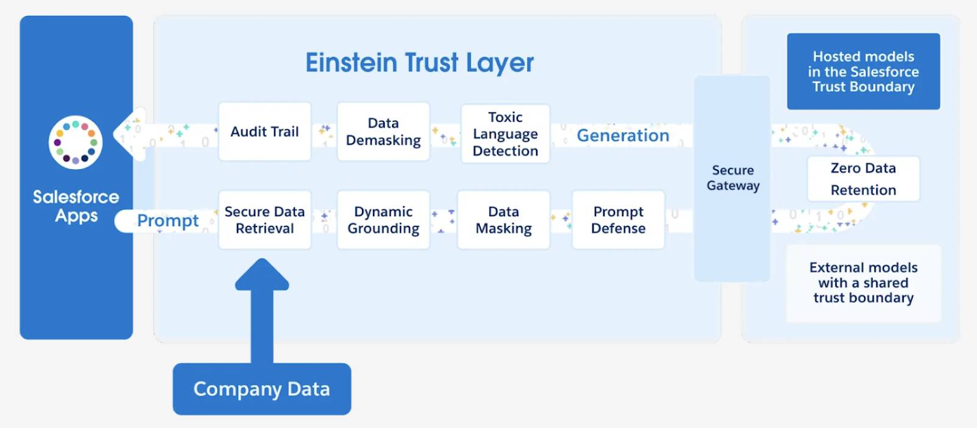
When you generate a response from a prompt built in Prompt Builder, the prompt is sent to the Einstein Trust Layer, which masks any sensitive data before sending it to the LLM. When prompts are sent to external models through the shared trust boundary, your data is encrypted to ensure its security in transit. Additionally, any sensitive information within the prompts is masked.
Finally, based on the “zero retention” standard, your data is never stored outside of Salesforce. For more information, check out the Einstein Trust Layer badge.
Resources
- Trailhead: Generative AI Basics
- Trailhead: Prompt Fundamentals
- Trailhead: Prompt Builder: Quick Look
- Trailhead: Einstein Trust Layer
Quiz

Create and Ground Prompt Templates
Learning Objectives
After completing this unit, you’ll be able to:
- Describe what grounding is.
- Use Prompt Builder to create a sales email prompt template.
- Add resources to a prompt template.
- Use an Apex class to provide data to a prompt template.
Trailcast
If you'd like to listen to an audio recording of this module, please use the player below. When you’re finished listening to this recording, remember to come back to each unit, check out the resources, and complete the associated assessments.
The Why and the How
In the Prompt Builder: Quick Look module, Linda Rosenberg, a Salesforce admin, aimed to reduce her sales team's manual workload by automating tasks with prompt templates. In this module, we take a deeper dive and show you why and how she did it.
Build a Sales Email Prompt Template

To create a sales email prompt template in Prompt Builder, you need the Einstein for Sales, Einstein for Platform, or Einstein for Service add-on.
Linda needs to create a template that her sales team can use to generate emails. She wants to reduce the time that the team spends on creating invitations to customers for product events.
To do this, Linda navigates to Prompt Builder in Salesforce Setup. When she navigates to Prompt Builder, the first page that’s shown is the Prompt Builder Explore page. Here you find:
- Guidance to help you learn more about the features of Prompt Builder.
- Access to prompt template walkthroughs and examples.
- A listing of all existing prompt templates with their type, category and status.
- Functionality to edit and delete existing prompt templates.
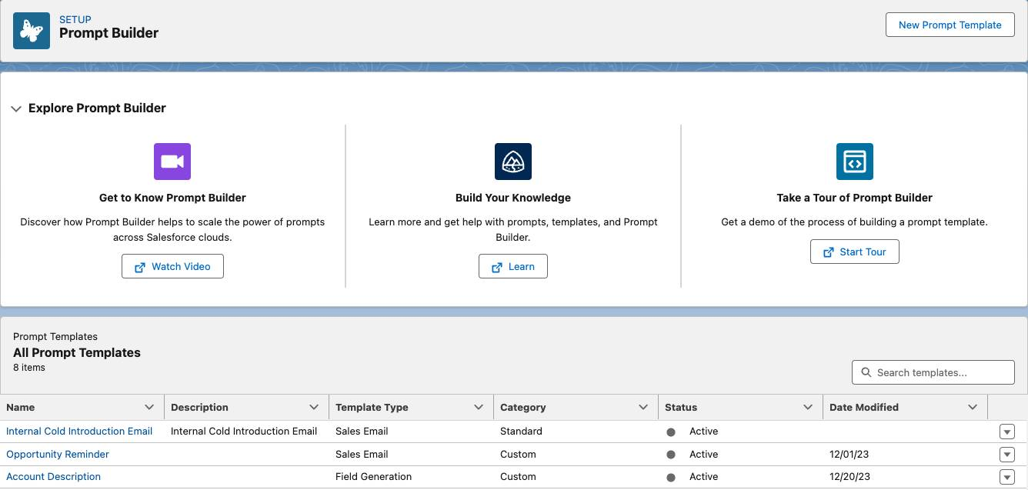
From the Explore page, Linda can also create a prompt template. She clicks the New Prompt Template button.
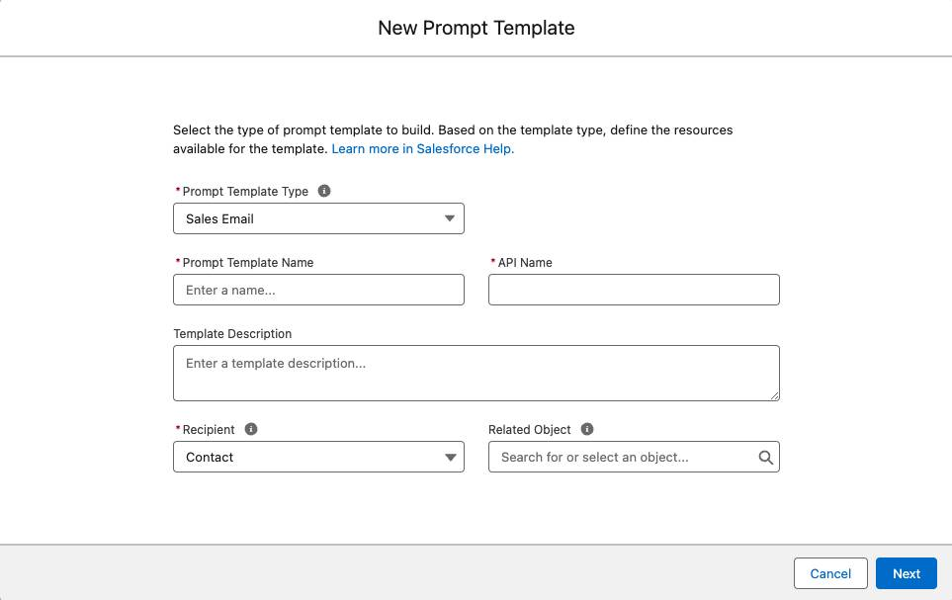
Linda starts to complete the fields in the template type setup screen.
When you set up a prompt template, it’s important to have a clear goal. In this case, Linda must think about who her company’s customers are and what the sales team wants them to see in the email.
Linda understands that her email may be sent to any Cloud Kicks contact. Therefore, Contact is the recipient object. She completes the template type setup by selecting:
- Prompt Template Type: Sales Email
- Prompt Template Name: Invite Customer to Local Product EventCopy
- API Name: Invite_Customer_to_Local_Product_EventCopy
- Template Description: Email customer to invite to local product event.Copy
- Recipient: Contact
- Related Object: Account
Ground Your Template
Making templates specific makes them effective. Another way of saying “specific” is to say your template is grounded.
Once Linda has defined her template type, she begins drafting and grounding her prompt in the Prompt Template Workspace.
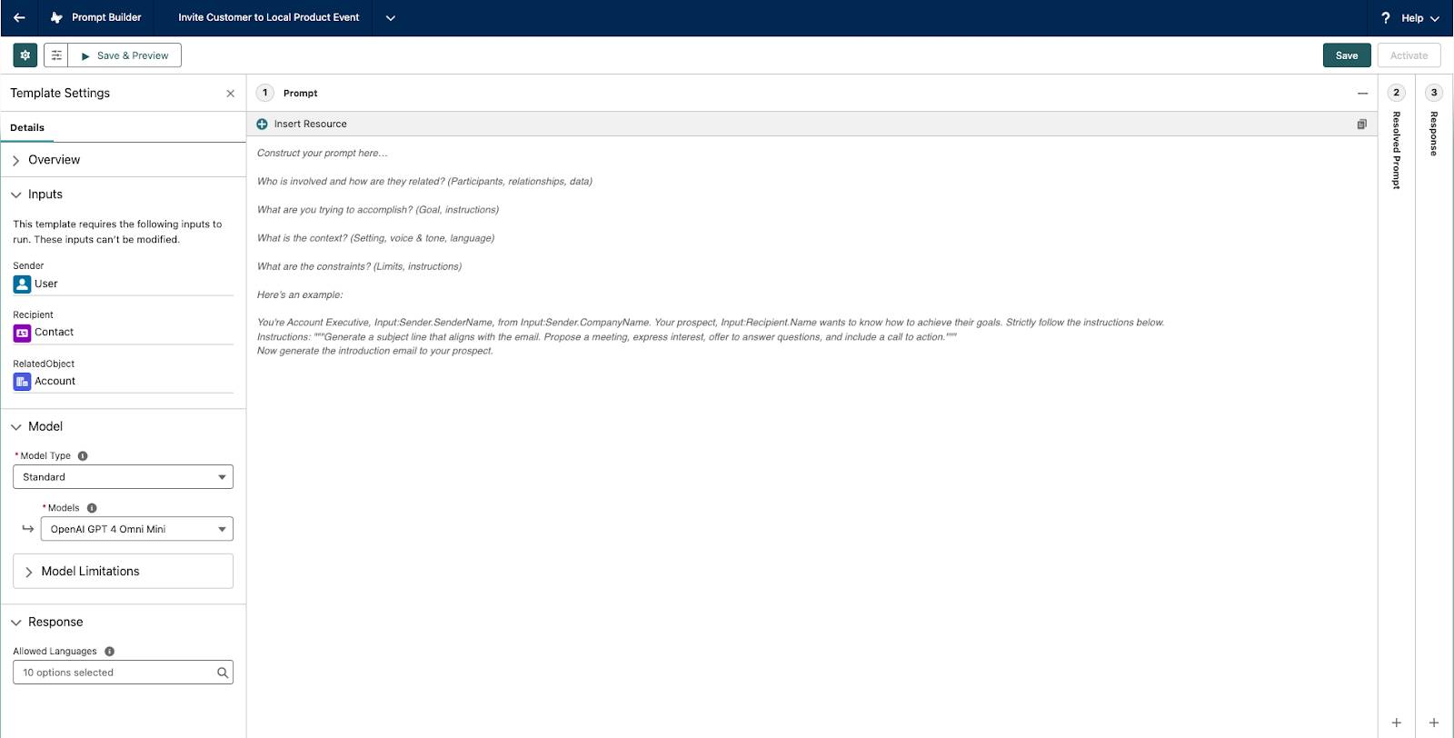
Linda includes the customer name, who the email is from, their titles, and details about the event.
You are a Salesforce admin and your name is Linda Rosenberg from the organization Cloud Kicks. Your prospect is Rob Hutchinson, a director from Acme Inc., and they are based in Toronto, Ontario.
In the email, invite the prospect to attend the event “Floating on Clouds: Toronto Kickoff” on September 18, an event for customers of Cloud Kicks new and old to network and preview upcoming products, in no more than 70 words. Explain to the prospect the possible benefits of attending the event and mention that you would be happy to chat with them further at the event or online if they need more information.
The prompt looks great. However, her first draft is hard-coded for only one specific sender and recipient. That would be okay if the prompt is going to be used once. But the concept of a prompt template is that it can be used for any sender and recipient. What she needs is a way to get her company’s CRM data into the template and ground it automatically.
Happily, Linda knows that she can use merge fields, Apex, and Flow as resources to enable Prompt Builder to securely access Salesforce data.
Add Merge Fields to a Prompt Template
Linda reviews her prompt and looks for areas where she can use merge fields to take her prompt from hardcoded for one-time use to reusable for any sender and recipient.
You are a Salesforce admin and your name is Linda Rosenberg from the organization Cloud Kicks. Your prospect is Rob Hutchinson, a director. They are based in Toronto, Ontario.
In the email, invite the prospect to attend the event “Floating on Clouds: Toronto Kickoff” on September 18, an event for customers of Cloud Kicks new and old to network and preview upcoming products, in no more than 70 words. Explain to the prospect the possible benefits of attending the event and mention that you would be happy to chat with them further at the event or online if they need more information.
Within the Prompt Template Workspace, Linda uses the Resources picklist to choose the type of resource to use. She sees there are multiple options for sales email prompt templates. Current Organization, Sender, and Recipient are all available to use in her prompt template.
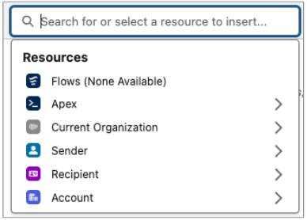
In the Resources picklist, Linda selects Sender and Recipient, where she then selects specific information, like title, name, company, and so on to ground her prompt template. She saves her work.
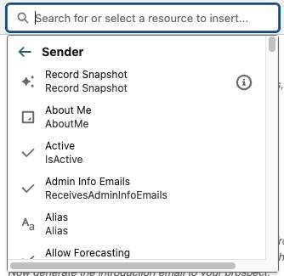 | 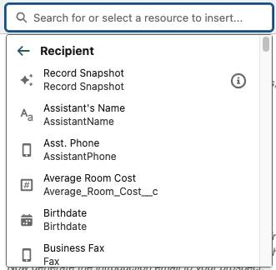

In this module you see the syntax {!$Resource}Copy in the prompt templates. This special syntax helps you to easily copy and paste the text from this module into the Prompt Template Workspace. It ensures all of your resources stay where and how you expected them in your template.
You are a {!$Input:Sender.Title}Copy and your name is {!$Input:Sender.Name}Copy from {!$Input:Sender.CompanyName}Copy. Your prospect is {!$Input:Recipient.Name}Copy, a {!$Input:Recipient.Title}Copy. They are based in {!$Input:Recipient.MailingCity}Copy.
In the email, invite the prospect to attend the event "Floating on Clouds: Toronto Kickoff" on September 18, an event for customers of Cloud Kicks new and old to network and preview upcoming products, in no more than 70 words. Explain to the prospect the possible benefits of attending the event and mention that you would be happy to chat with them further at the event or online if they need more information.
After she’s done, she notices there’s one piece of her prompt that needs an adjustment before it can display the correct response: "Floating on Clouds: Toronto Kickoff" on September 18.
At Cloud Kicks, “Floating on Clouds” is a nationwide event that hosts local customers based on their city. Linda wants to make sure the sales email prompt template is as personalized as possible and generates emails that invite customers to local events.
Linda understands that using only merge fields for this portion isn't enough. She needs logic incorporated into her prompt template. There are several approaches to accomplish this within Prompt Builder, including using Apex or Template-Triggered Prompt Flows. First, let’s explore how to use Apex in prompt templates.
Add Apex to a Prompt Template
If you want to use data from a SOQL query or an external API in your prompt, consider Apex. Apex is also effective if you want to generate well-formatted JSON or do programmatic data filtering.
In this case, Linda wants to create an Apex class that finds events that are close to a given contact and returns the name of the event, subject, location, and start time. Using the Developer Console she creates a class named ContactEventsCopy with a method annotated as InvocableMethodCopy. The InvocableMethodCopy must accept List<Request>Copy where the inputs defined in the RequestCopy class match the inputs within the prompt. Also, the InvocableMethodCopy must be labeled with the CapabilityTypeCopy that matches the template type.

If you are interested in learning more about adding Apex classes to prompt templates or to see code samples, check out the Salesforce Documentation.
Once her class is created, Linda returns to the Prompt Template Workspace in Prompt Builder and notices that Apex is now a resource. She adds the Apex class by clicking Resources and selecting Apex.
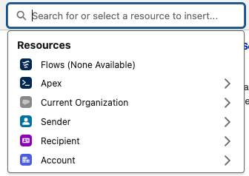 | 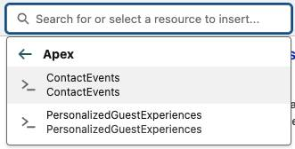

You’re a {!$Input:Sender.Title}Copy and your name is {!$Input:Sender.Name}Copy from {!$Input:Sender.CompanyName}Copy. Your prospect is {!$Input:Recipient.Name},Copy a {!$Input:Recipient.Title}Copy.
They are based in {!$Input:Recipient.MailingCity}Copy.
In the email, invite the prospect to attend an event for customers of Cloud Kicks
new and old to network and preview upcoming products, in no more than 70 words.
Explain to the prospect the possible benefits of attending the event and mention
that you would be happy to chat with them further at the event or online if they need
more information.
Add the following event information to the email: {!$Apex:ContactEvents.Prompt}Copy.
Great! Now instead of referencing one single event. Linda can rely on her Apex class to return an event close to the specified contact.
Resources
- Salesforce Help: Ground with Apex Merge Fields
- Salesforce Help: Set Up Sales Emails
- Trailhead: Prompt Fundamentals

Build a Field Generation Prompt Template
Learning Objectives
After completing this unit, you’ll be able to:
- Use Prompt Builder to create a field generation prompt template.
- Create a flow that sends data to a prompt template.
- Create a flex prompt template.
Trailcast
If you'd like to listen to an audio recording of this module, please use the player below. When you’re finished listening to this recording, remember to come back to each unit, check out the resources, and complete the associated assessments.
A field generation prompt template is a specific type of prompt template that's designed to return a generated response from an LLM to a specific field on a record. Field generation prompt templates have a direct relationship to record fields. With the help of Lightning App Builder (LAB), an Einstein button () can trigger an assigned prompt template to send a prompt to the LLM and return a response back to the specific field.
Linda wants to help customer support agents quickly come up to speed to help any Cloud Kicks customer. She'll utilize a field generation prompt template to generate a summary of the related case comment history when the agent clicks the Einstein button for a case summary field.
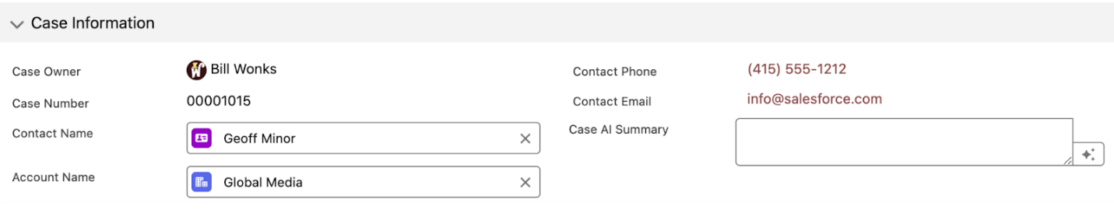
To configure the Einstein button and generate the LLM response, Linda needs two things.
- A field generation prompt template created with Prompt Builder.
- A field added to a component and configured in LAB.
Create a Field Generation Prompt Template
Linda opens Prompt Builder and creates a new prompt template. She selects her prompt template type, and completes the template setup by selecting:
- Prompt Template Type: Field Generation
- Prompt Template Name: Case Comments SummaryCopy
- API Name: Case_Comments_SummaryCopy
- Template Description: Summary of case details.Copy
- Object: Case
- Object Field: Case_AI_Summary__c
After the prompt template setup is complete, she creates her prompt template in the Template Workspace.
You are a support representative who is tasked with creating a short summary of a case that happened between a customer and a company support rep.
She clicks Save and Activate to access the template within LAB. Now that Linda has a ready-to-use prompt template, she needs to create a Case AI Summary field on the Case record page.
Configure a Field in LAB to Connect Field Generation Prompt Templates
To use an Einstein button to trigger a field generation prompt template in a record, Linda must configure the field in Lightning App Builder (LAB). To start, she can select an existing Lightning Record page or create a new one.
Linda can drag either a Record Detail component or a Field Section component onto the selected page.
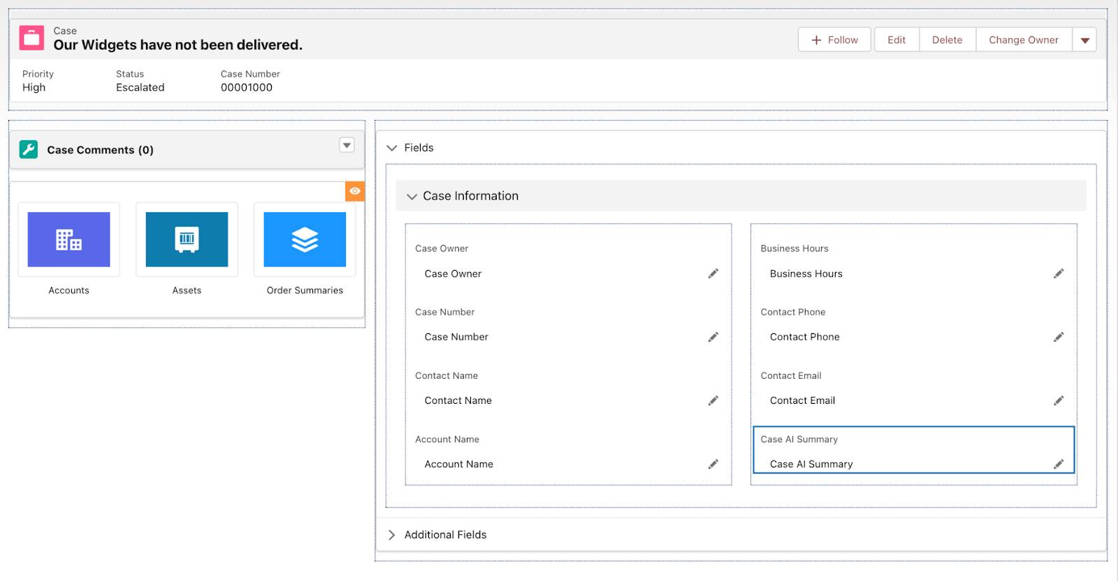
- For a Field Section component: Linda can drag a form field onto the Field Section component.
- For a Record Detail component: Linda must migrate the component to Dynamic Forms. She can do this migration by selecting Upgrade from the right-hand panel and following the steps in the upgrade wizard. This change allows her to configure fields from her existing record pages as individual components.
Linda can select any form field that supports field generation, including writable text, text area, text area (long), and text area (rich) field types. Field generation prompts aren't compatible with read-only fields.
In the Einstein Generative AI section of the Field Properties panel, she selects a Field Generation prompt template to assign to the form field.
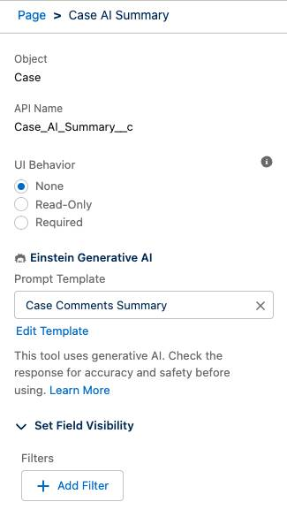
Linda then saves and activates the record page.
Linda understands she needs to incorporate real-time data into her prompt template to make it relevant. This can be invoked from a flow.
Add a Flow to a Prompt Template
With the help of Flow Builder, admins can create Template-Triggered Prompt Flows to incorporate complex logic in prompt templates without writing any code. In Flow Builder, Linda creates a Template-Triggered Prompt Flow for her Case Comments Summary prompt template. Flows with the Template-Triggered Prompt Flow type run only from a prompt template.
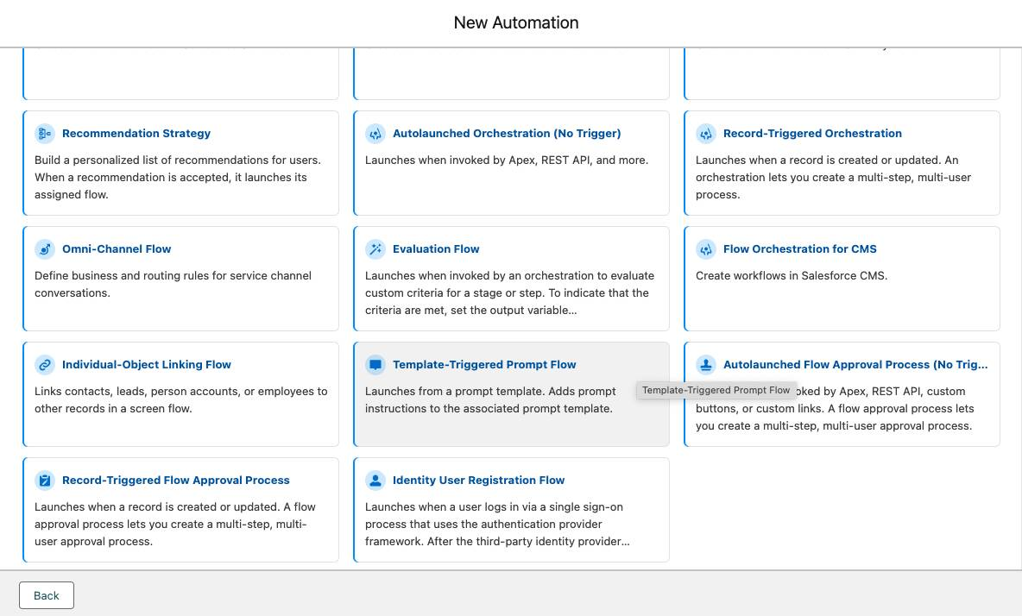
After Flow Builder loads, Linda types templateCopy in the Search Automations box and selects Template-triggered Prompt Flow. Then Linda enters this information in the Start panel.
- Select Input Type: Automatic Inputs
- Prompt Template Type: Field Generation Template Capability
Remember, when Linda created the prompt template, she selected the Prompt Template Type “Field Generation”. So here, she sets the Prompt Template Type to match.
- Object: Case
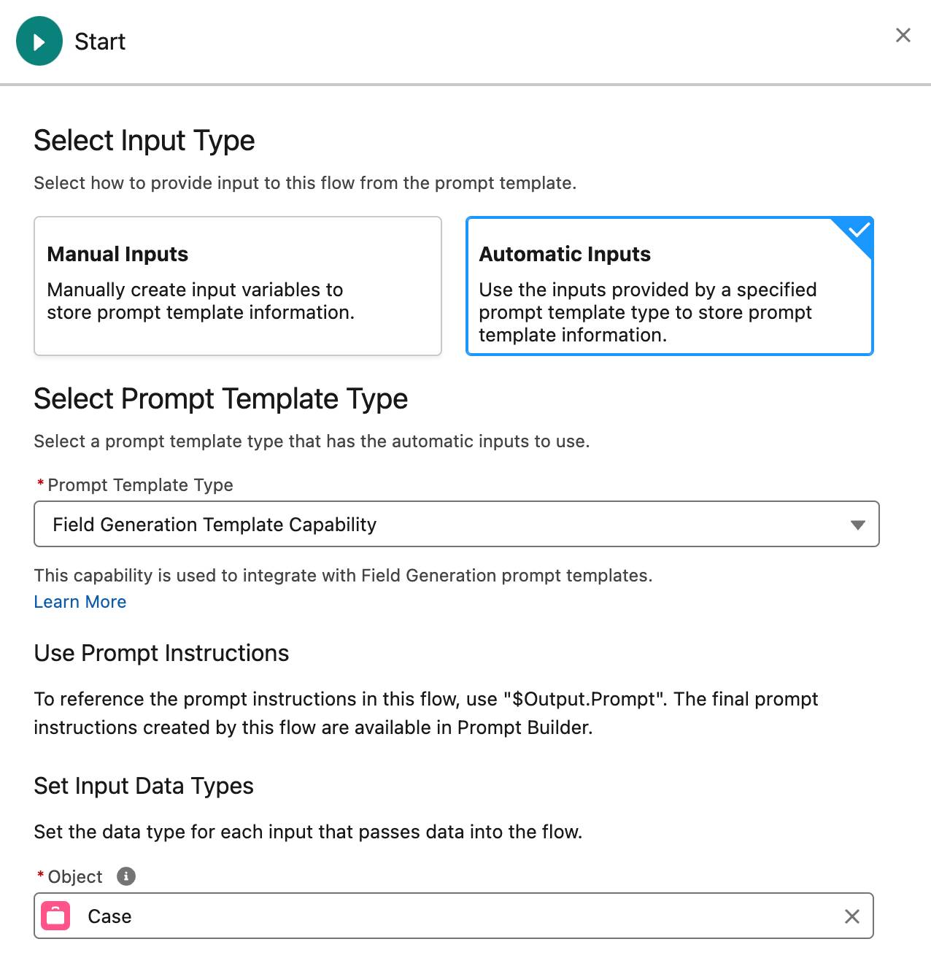
Linda wants the prompt to include all of the case’s comments, so she adds a Get Records element to retrieve and store them in a collection.
- Label: Get Case CommentsCopy
- Object: Case Comment
- Field: Parent ID
- Operator: Equals
- Value: select Prompt Template Input then Case then Case ID
- How Many Records to Store: All records
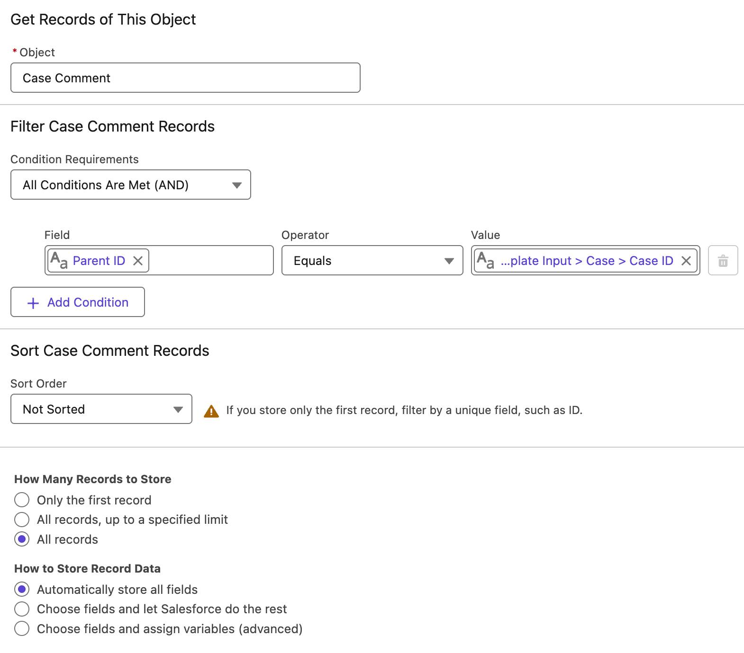
Linda wants the case summary to specify when the case has no comments, so she adds a Decision element after the Get Records element.
- Label: Comments Found?Copy
- First Outcome Details:
  - Label: YesCopy
  - Resource: Case Comments from Get Case Comments
  - Operator: Is Empty
  - Value: False
- Default Outcome Label: NoCopy
This element splits the flow into two paths: one that the flow takes when comments are found on the current record, and one that it takes when no comments are found.
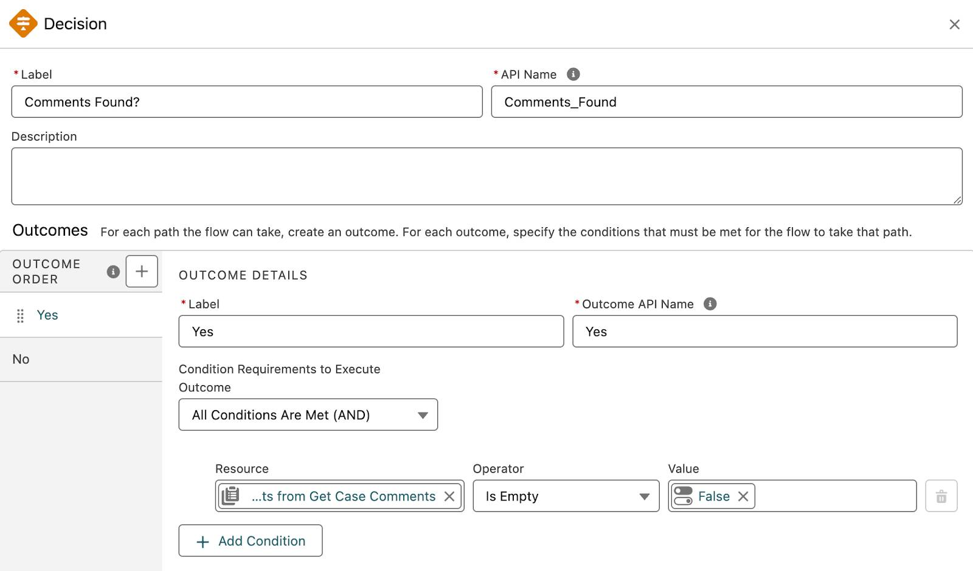
To send the collected comment data to the prompt for summarization, Linda uses the Add Prompt Instructions element. But this element can’t receive the comment data in its current form. The collection created by the Get Case Comments element contains all the data from the related Case Comment records. Linda wants only the comments, so the flow must first separate the comment text from the rest of each record. Additionally, the Add Prompt Instructions element must receive data one record at a time.
Loops are the perfect tool for this situation. A loop looks at a record, does something with that record, and repeats that process until it has processed all of the records in the collection. Linda adds a Loop element on the Yes path.
- Label: Loop CommentsCopy
- Collection Variable: Case Comments from Get Case Comments
- Direction: First item to last item
Now Linda adds an Add Prompt Instruction element to the Yes path. Think of the Add Prompt Instruction element like a direct channel between your flow and the prompt. Everything in the element’s prompt instructions is merged directly into the prompt that ran the flow. For example, if the Add Prompt Instruction element’s Prompt Instructions field contained the formula “{!test}”, the prompt would add the result of that formula to the prompt template.
- Label: Send Comments to PromptCopy
- Prompt Instructions: Enter “Summarize the case's comments usingCopy”.
- Click in the Insert a resource field, then select Current Item from Loop Loop_Comments, and then select CommentBody.
This resource merges the current case comment’s text into the prompt instructions.
On the No path, Linda adds another Add Prompt Instructions element. This element tells the prompt template that no comments were found.
- Label: No Comments for PromptCopy
- Prompt Instructions: The case has no comments to summarize.Copy
Linda’s flow now looks like this.
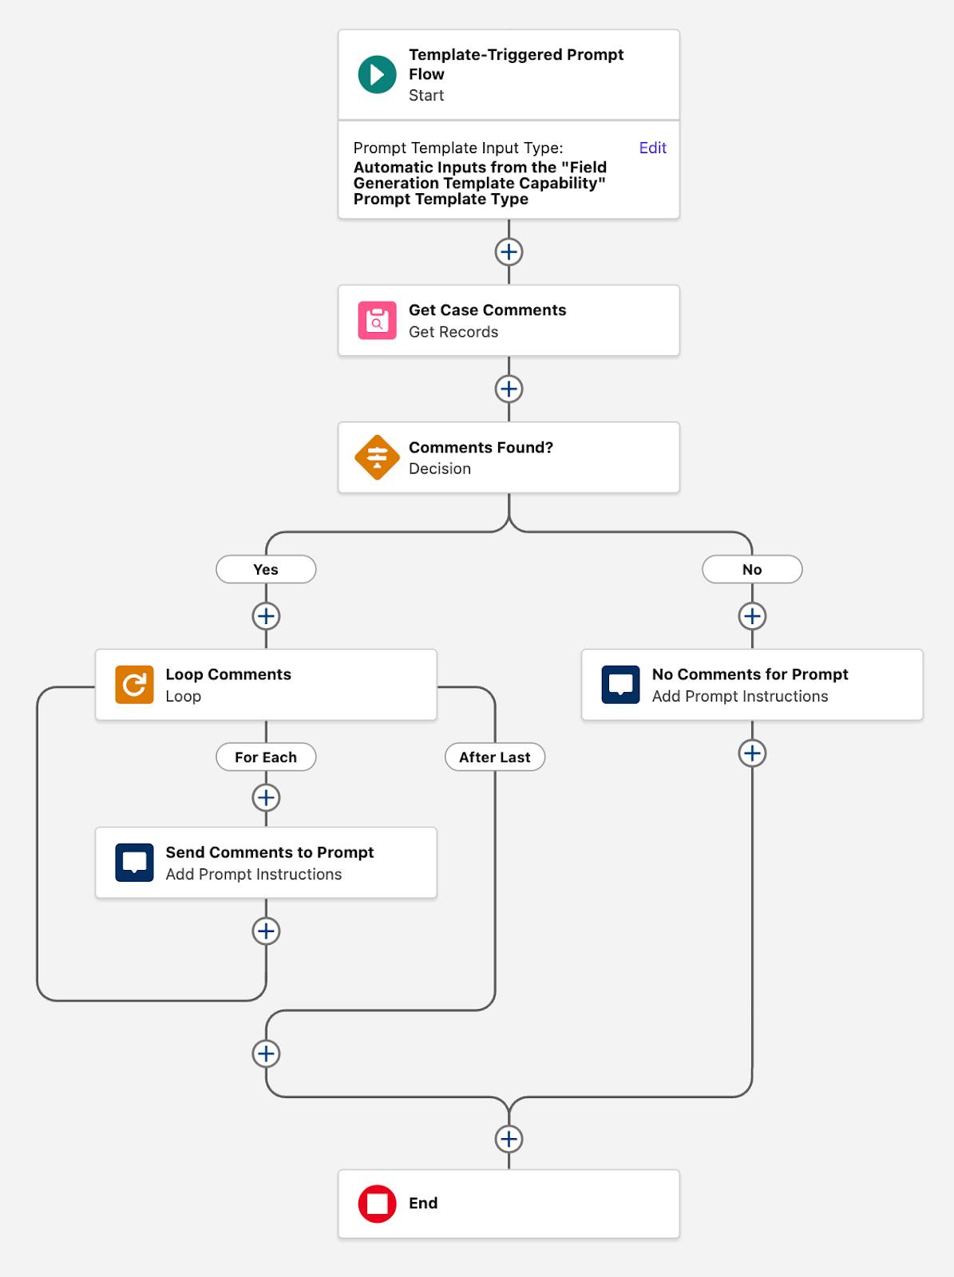
When she saves and activates the Flow, it’s immediately available in Prompt Builder to use for any Field Generation prompt template whose object is Case.
After Linda activates her flow in Flow Builder, she navigates to the Resources list in the Prompt Templates Workspace and notices that Flows is now a resource category. When she selects Flows, she sees her new template-triggered prompt flow, Get Case Summary.
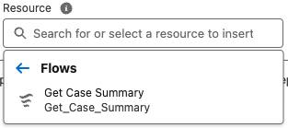
She selects Get Case Summary, and her new flow is inserted into the prompt template as {!$Flow:Get_Case_Summary.Prompt}Copy.
You are a support representative who is tasked with creating a short summary of a case that happened between a customer and a company support rep.
"""
Case Data:
{!$Flow:Get_Case_Summary.Prompt}Copy
"""
Now Linda’s ready to test her prompt template to see the results.
Build a Flex Prompt Template
So far we’ve covered Sales Email and Field Generation prompt templates. However, if your specific use case doesn't align with those templates, Prompt Builder offers flexibility for all scenarios. Unlike other prompt templates, Flex template inputs aren’t predefined; instead, you choose them during template creation. In Prompt Builder, you have the option to add up to five inputs to a Flex template. Once defined, the resource picker shows these inputs, and your prompt template can reference them using merge fields.
Linda wants to use Prompt Builder to create a product description using the account name, asset details, and contact information. Since the Field Generation prompt template doesn't offer the necessary input choices in terms of quantity (three) and type (account, asset, and contact) for her needs, she decides to create a Flex prompt template. Linda completes the setup and creates her prompt template.
- Prompt Template Type: Flex
- Prompt Template Name: Product DetailsCopy
- API Name: Product_DetailsCopy
- Template Description: Information about productCopy
- Define a resource for account information:
  - Name: Account InfoCopy
  - API Name: Account_InfoCopy
  - Object: Account
- Define a resource for asset information:
  - Name: Asset InfoCopy
  - API Name: Asset_InfoCopy
  - Object: Asset
- Define a resource for contact information:
  - Name: Contact InfoCopy
  - API Name: Contact_InfoCopy
  - Object: Contact
Write a detailed product description using this information:
The Account Name is {!$Input:Account_Info.Name} Copy
The Product Info is {!$Input:Asset_Info.Description} Copy
The Contact Info is {!$Input:Contact_Info.Name} Copy
Well done. You learned that Prompt Builder is flexible enough to accommodate your everyday business needs. Whether you choose to use a flow or create an Apex class, Prompt Builder helps minimize the time spent on your daily tasks.
Resources
- Salesforce Help: Break Up Your Record Details with Dynamic Forms
- Salesforce Help: Field Generation Prompt Templates in Action
- Trailhead: Prompt Fundamentals
- Trailhead: Build Flows with Flow Builder

Review, Revise, and Save Prompt Templates
Learning Objectives
After completing this unit, you’ll be able to:
- Recall how to increase accuracy and limit toxicity in a prompt response.
- Discuss how to review and revise a prompt response.
Trailcast
If you'd like to listen to an audio recording of this module, please use the player below. When you’re finished listening to this recording, remember to come back to each unit, check out the resources, and complete the associated assessments.
Preview Your Prompt
After Linda drafts her Flex prompt template, it’s time to test. The Prompt Template Workspace includes several key sections to support this process:
- Prompt: Create your prompt template, add resources, and define instructions.
- Resolved Prompt: View how the prompt and resources are resolved for selected records. Masked data appears here, and merge field resources show associated CRM field values. Flow resources display their outputs.
- Response: Review the LLM-generated output based on your resolved prompt. The side panel contains the Template and Preview Settings to tailor the results to you. The Template Settings include the list of available LLMs, their limitations, and how you want the response to be shown.
When you use a Flex prompt template and define three or more inputs for it, you see a section called Inputs in the Preview Settings.
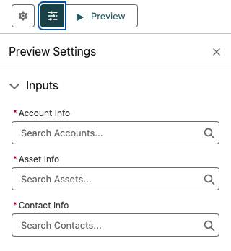
Prompt Builder walks users through the end-to-end process of creating and testing prompts. Each time you revise the template and regenerate the preview, Einstein updates the resolved prompt and LLM response. Repeat as needed to fine-tune your prompt and ensure safe, effective outputs.
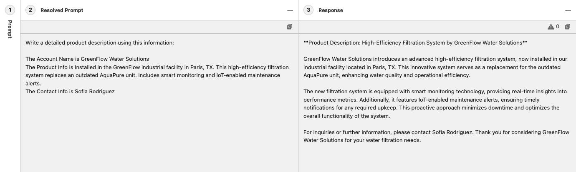
Linda uses the Response section to view what comes from the LLM. Viewing the immediate Response allows Linda to assess whether adjustments to the template are necessary.
Linda wants to test the sales email prompt template from the previous unit. Let’s see how this looks in the Response. The following is Linda’s sales email prompt from unit two.
You’re a {!$Input:Sender.Title}Copy and your name is {!$Input:Sender.Name}Copy from {!$Input:Sender.CompanyName}Copy. Your prospect is {!$Input:Recipient.Name}Copy a {!$Input:Recipient.Title}Copy. They are based in {!$Input:Recipient.MailingCity}Copy.
In the email, invite the prospect to attend an event for customers of Cloud Kicks new and old to network and preview upcoming products, in no more than 70 words. Explain to the prospect the possible benefits of attending the event and mention that you would be happy to chat with them further at the event or online if they need more information.
Add the following event information to the email: {!$Apex:ContactEvents.Prompt}Copy.
Review a Generated Response
Linda can select which objects are used to test her prompt template. Linda selects the recipient record (Andy Smith - Contact) and then clicks Save & Preview. Linda can now view the “resolved” prompt template, which is the prompt after the merge fields have been replaced with the selected record data.
You’re a Salesforce admin and your name is Linda Rosenberg from Cloud Kicks. Your prospect is Andy Smith a sales manager. They are based in Toronto.
In the email, invite the prospect to attend an event for customers of Cloud Kicks new and old to network and preview upcoming products, in no more than 70 words. Explain to the prospect the possible benefits of attending the event and mention that you would be happy to chat with them further at the event or online if they need more information.
Instructions:
"""
Add the following event information to the email:
Event Name: Floating on Clouds: Toronto
Description: Cloud Kicks invites you to an unforgettable night of custom shoe magic. From innovative designs to personalized fits, this VIP event is where style meets performance.
Location: Toronto, Ontario
Time: 9/18, 2:00 PM
-
Event Name: Floating on Clouds: Houston
Description: Join us at our exclusive nationwide event where you’ll be the first to witness the hottest, limited-edition athletic kicks.
Location: Houston, Texas
Time: 7/17, 3:00 PM
-
End the email with a clear call to action to attend the event.
"""
In Linda’s test, the template returns all of the events hosted by Cloud Kicks. This is expected and shows the power of using Apex within prompt templates. The ContactEvents Apex class Linda created returns any upcoming event hosted by Cloud Kicks. The template provides the LLM with all the information it needs to aggregate or simplify the data output.
Next, you can see that in the Response, based on the specific instructions in Linda’s prompt template, Einstein is able to generate an email based on Salesforce data. Nice!
Subject:
Join us at Floating on Clouds: Toronto!
Body:
Dear Andy Smith,
I hope this email finds you well. I wanted to personally reach out and extend an invitation to an exciting event near you. Cloud Kicks is hosting an exclusive VIP event called Floating on Clouds: Toronto.
At this event, you will have the opportunity to experience the magic of custom shoe designs and personalized fits. It's where style meets performance, and we guarantee it will be an unforgettable night.
Event Name: Floating on Clouds: Toronto
Date: 9/18, 2:00 PM
Location: Toronto, Ontario
We understand that you may have questions about our products and how they can enhance your athletic performance. I want to assure you that our team will be available at the event to answer any inquiries you may have.
Please mark your calendar for this exclusive event and join us on 9/18 at 2:00 PM in Toronto, Ontario. We would be thrilled to have you there!
If you have any questions or need further information, please don't hesitate to reach out to me directly. I am here to assist you.
Looking forward to seeing you at Floating on Clouds: Toronto!
Best regards,
Linda Rosenberg
Salesforce Admin
Cloud Kicks
Guard Against Toxicity
So far so good, but there’s more to discover about crafting exceptional content with generative AI. Large language models are trained on huge amounts of data. This fact puts the model at risk for producing toxic verbiage that could leak into your responses. To avoid this risk, you need to add limits and guardrails to prompt templates.
Let’s check out seven things to think about when creating guardrails to assist with response accuracy, appropriateness, and avoiding toxicity.
Considerations After Generating a Prompt Response
Topic | Description | Example Prompt Text Instructions (where applicable)
Topical Relevance | The model’s response must be grammatically correct within the ongoing conversation and directly relevant with the overall request in the prompt.
Action/Goal Completion | Assess if the response aligns with the intended action, fulfills the goal of the prompt, and satisfies the user's need by addressing everything the prompt requests.
Register/Tonal Appropriateness | When evaluating model output, consider whether the tone of voice or style is appropriate for the interaction between the response and the user. Ensure the vocabulary, punctuation, and style fit the needs of your end user. | Keep the emotion of the summary relaxed.
Factual Accuracy | When reviewing model output, watch for inaccuracies or hallucinations. Check if it correctly uses prompt data and avoids including unintended specifics. | Follow the instructions precisely, don’t add any information not provided.
Repetition | Consider the extent of variation in the response for your specific use case. Evaluate whether it meets your expectations. Consider if repetitive vocabulary is acceptable for tighter compliance. Also, decide if it’s OK if multiple responses sound the same or use the same terms. | Use clear, concise, and straightforward language using the active voice and strictly avoiding the use of filler words and phrases and redundant language.
Toxicity | Review the response for any potentially harmful content, such as offensive, disrespectful, or abusive language that could negatively impact the user experience.
Bias/Ethics | Verify that the response promotes fairness and inclusivity.  Examine the response for subtle biases in language. Ensure it doesn’t:  - Assume gender identity based on their name alone.  - Sideline participants with disabilities.  - Display assumptions about race or socioeconomic status. | You must treat equally any individual or person from different socioeconomic statuses, sexual orientations, religions, races, physical appearances, nationalities, gender identities, disabilities, and ages. When you do not have sufficient information, you must choose the unknown option, rather than making assumptions based on any stereotypes.
Now that you understand what to look for when reviewing prompt templates, let’s return to the sales email prompt template and create a new version that includes the guardrails.
Saving and Versioning Prompt Templates
Prompt Builder gives users the flexibility to easily modify or version a prompt template when necessary. Navigate to the Prompt Template Workspace, select and modify your prompt template. After you do so, you can test it again by selecting a recipient or record and clicking Save & Preview.
Linda is ready to update her prompt template to include guardrails. With her existing prompt template open, she clicks Save As. There are two options listed.
- Save as a New Version: Provides access to incremental changes to the same prompt template with the same template name.
- Save as a New Template: Creates a new prompt template with a new template and API name.
Linda is interested in creating a new version. She selects Save as a New Version.

In the following prompt template, the text shows the revisions that Linda added to help ensure the responses are trusted and free of bias and toxicity.
You’re a {!$Input:Sender.Title}Copy and your name is {!$Input:Sender.Name}Copy from {!$Input:Sender.CompanyName}Copy. Your prospect is {!$Input:Recipient.Name},Copy a {!$Input:Recipient.Title}Copy. They are based in {!$Input:Recipient.MailingCity}Copy.
In the email, invite the prospect to attend an event for customers of Cloud Kicks new and old to network and preview upcoming products, in no more than 70 words.Explain to the prospect the possible benefits of attending the event and mention that you would be happy to chat with them further at the event or online if they need more information.
You must treat equally any individuals or persons from different socioeconomic statuses, sexual orientations, religions, races, physical appearances, nationalities, gender identities, disabilities, and ages. When you do not have sufficient information, you must choose the unknown option, rather than making assumptions based on any stereotypes.
Instructions:
"""
Follow the instructions precisely, do not add any information not provided.
Summarize in 1 sentence, and use clear, concise, and straightforward language using the active voice and strictly avoiding the use of filler words and phrases and redundant language.
Keep the emotion of the summary relaxed.
In the email, invite the prospect to attend the event in no more than 70 words.
Add the following event information to the email: {!$Apex:ContactEvents.Prompt}Copy.
After you reviewed and revised the prompt template, simply click Save and Activate and the template is ready for use.

The active version of a template is the version that will be used by other features. For example, when a user drafts an email or generates record fields with Einstein, the active version of the template is what gets used.
Great work! At this point you can invite your colleagues to send those emails or use those suddenly smarter record fields. Just make sure everyone understands that they have a responsibility to be the “human in the loop” and review responses before using them.
Prompt Builder puts power into the hands of admins to define prompt templates. It delivers personalized output while bringing the entire Customer 360 to your fingertips.
Resources
- Trailhead: Prompt Fundamentals

Autonomous Agents

Get to Know Autonomous Agents
Learning Objectives
After completing this unit, you’ll be able to:
- Define what an autonomous agent is and how it works.
- List some real-world examples of autonomous agents in different industries.
Trailcast
If you'd like to listen to an audio recording of this module, please use the player below. When you’re finished listening to this recording, remember to come back to each unit, check out the resources, and complete the associated assessments.
The Power of Autonomous Agents
The Rodriguez family is eager for a stress-free vacation. Luckily, they discover Coral Cloud Resorts, which has an autonomous AI assistant that helps them set up every aspect of their trip.
They use the resort’s AI-powered concierge agent to seamlessly book flights, secure a hotel, arrange transportation, and even select the best Coral Cloud experiences and dining reservations based on their preferences. The agent customizes an itinerary to suit each family member’s interests and provides a detailed packing list with helpful reminders.
With the agent managing all the logistics and curating what’s sure to be a magical experience, the Rodriguez family arrives at Coral Cloud Resorts relaxed and ready to create unforgettable memories.

How Do Autonomous Agents Work?
Autonomous agents like Coral Cloud’s understand and respond to requests, and then act without human intervention. Give the agent a goal, and it generates tasks for itself, completes them, and moves on to the next one until the goal is achieved. Unlike traditional chatbots that follow predefined rules, autonomous agents operate in dynamic environments, making them perfect for complex tasks in customer service, marketing, commerce, sales, and more.
While autonomous agents don’t need human help to complete their tasks, they still need you to describe the ideal goals and main objectives you want to achieve. Once in action, the agent can save your business significant time and resources and allow you to focus on improving the overall customer experience and driving growth–just like at Coral Cloud Resorts.
You might think setting up an agent takes a lot of time, but autonomous agents‌ require less time to build compared with traditional bots. And they can do more when you set them up with the right data and actions. Let’s take a look at the key components that make them effective.
Data
Data is the foundation of an autonomous agent's functionality. It’s what enables an agent to make informed decisions and execute tasks autonomously. At Coral Cloud Resorts, the concierge agent analyzes opt-in data about the Rodriguez family, including family member profiles, past travel history, and more, to gain a deeper understanding of their preferences. With these insights, the agent can personalize every aspect of their trip and provide a seamless and enjoyable vacation.
Decision-Making
When an autonomous agent analyzes data, it uses advanced decision-making algorithms to prioritize and execute tasks efficiently. For the concierge agent at Coral Cloud Resorts, that means evaluating various options and scenarios to ensure that every decision aligns with the Rodriguez family’s preferences and goals.
Action Execution
After making data-driven decisions, the agent seamlessly transitions to executing the planned actions. For the concierge agent, those planned actions might be autonomously reserving hotel rooms, arranging transportation, and more. This not only enhances the customer experience but also allows the business to save an immense amount of time and focus on other critical tasks that provide even better customer service.
Learning and Adaptation
Over time, the agent continuously learns from each interaction and adapts to improve future performance. It analyzes feedback and outcomes to refine its algorithms and decision-making processes to better meet the customer’s needs.
In addition, autonomous agents are adaptable to various situations and can provide data-driven solutions to simplify and improve efficiency in a wide range of areas. Let’s take a look at that next.
Autonomous Agents in Action
Autonomous agents are becoming increasingly universal and offer support in a wide range of fields. Here are some industries where they bring significant benefits and support to CRM platforms.
Healthcare
An autonomous agent can engage with patients, providers, and payers to resolve inquiries, provide summaries, and take action. For example, a patient services agent can answer simple patient questions, help schedule appointments with the best physician, review coverage benefits, generate medical history summaries, and approve care requests.
Example: A patient needs to schedule a follow-up appointment with a specialist. They use the healthcare provider’s agent to request the appointment. The autonomous agent checks the availability of the best-suited specialist, confirms the patient’s insurance coverage, and schedules the appointment. The agent also generates a summary of the patient’s medical history and sends it to the specialist in advance. This streamlined process ensures that the patient receives timely care and reduces the administrative burden on healthcare staff.
Financial Services
Banks can autonomously manage transaction disputes through various channels such as the banking app, SMS, website, or phone. Prebuilt service flows allow agents to file complaints, meet regulatory reporting requirements, verify transaction history, alert merchants, and even issue provisional credits or new cards. These autonomous agents only escalate to a human for final authorizations, saving time and allowing human experts to focus on more complex interactions.
Example: A customer notices a fraudulent transaction on their bank statement and reports it through the banking app. The autonomous agent verifies the transaction history, files the complaint, and issues a provisional credit to the customer's account. The agent also alerts the merchant and schedules a follow-up with a human representative for final authorization. This process, which used to take several days, is now completed within hours, significantly improving customer satisfaction and reducing the workload on human service reps.
Insurance
Insurance companies can autonomously update coverage, extend better pricing to qualified policyholders, update beneficiaries, schedule and deploy claims adjusters, and even issue claims checks or policy renewals—all without human intervention. Wealth advisors reported that 67% of their daily work is non–value-added administrative work. Autonomous agents can reduce this by planning, scheduling, and summarizing client meetings, drafting client communications, and ensuring compliance by routing communications to the proper licensed supervisors.
Example: An insurance policyholder wants to update their beneficiary information. They use the insurance company’s mobile app to make the change. The autonomous agent verifies the policyholder’s identity, updates the beneficiary’s information, and sends a confirmation email. The agent also ensures that the change is compliant with regulatory requirements by routing the communication to a licensed supervisor for a final review. This process, which previously required a phone call and manual processing, is now completed in seconds, freeing up the policyholder's time and reducing administrative workload.
Retail
Autonomous agents can share campaign insights, proactively manage customer outreach, and resolve cases for retailers. A personal shopper autonomous agent acts like a digital concierge for online shoppers, using generative AI to help customers on ecommerce sites, chat, or messaging apps like WhatsApp. While basic chatbots only solve predefined questions, autonomous AI agents learn from shoppers’ behavior and preferences and can provide natural language searches, conversational responses, and quick cart additions for instant checkout.
Example: A customer is shopping for a new pair of shoes on an ecommerce site. The personal shopper autonomous agent, integrated into the chat feature, engages with the customer and analyzes their past purchases and preferences. Using this information, the agent recommends a pair of shoes that perfectly match the customer’s style and size. The customer can then add the shoes to their cart and complete the purchase with a single click. To further enhance the experience, the agent follows up with a personalized thank-you message and suggests complementary accessories. This thoughtful approach not only delights the customer but also increases the likelihood of repeat business.
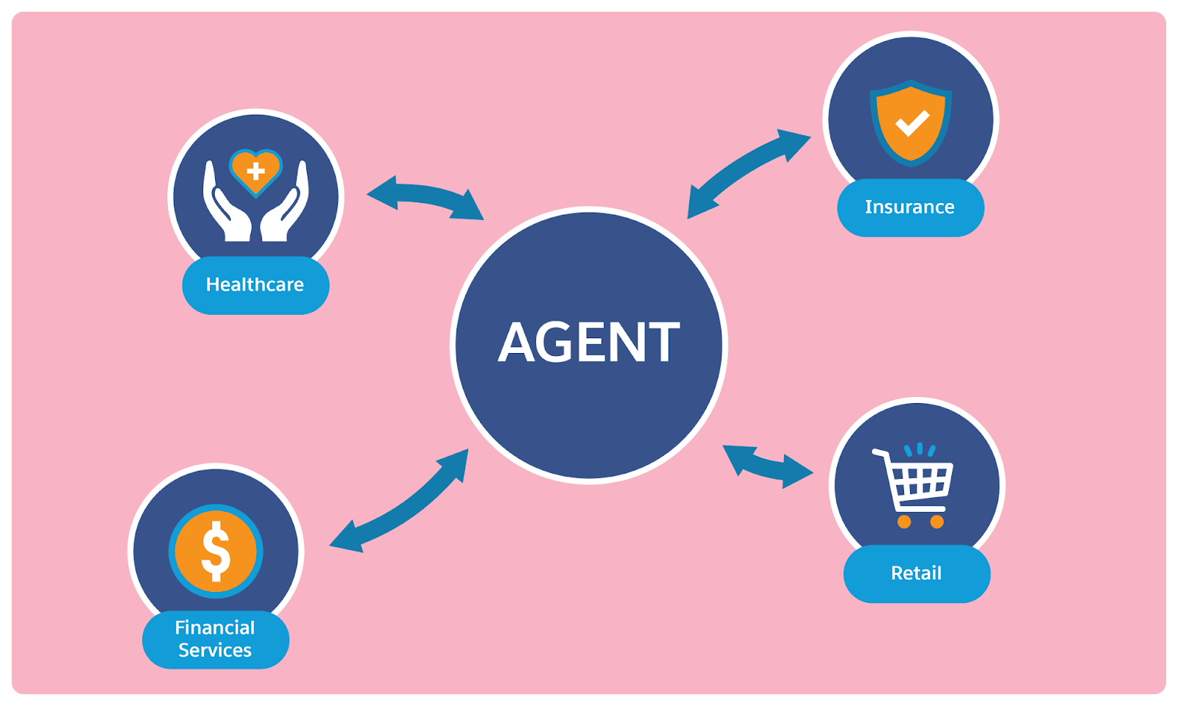
In this unit, you learned that autonomous agents are like intelligent digital assistants that can operate independently without direct human supervision. They can reason, plan, and take action to achieve specific tasks or goals once you equip them with the relevant data and the knowledge and experience of human experts. Next, learn how to provide a safe and trusted autonomous agent experience for your customers.
Resources
- Salesforce Blog: What are Autonomous Agents? A Complete Guide

Establish Trust with Autonomous Agents
Learning Objectives
After completing this unit, you’ll be able to:
- Explain why it’s important to implement safety precautions with autonomous agents.
- List seven guardrails that keep autonomous agents safe and trusted.
Trailcast
If you'd like to listen to an audio recording of this module, please use the player below. When you’re finished listening to this recording, remember to come back to each unit, check out the resources, and complete the associated assessments.
Make Safety Your #1 Priority
Implementing autonomous agents into your workflow brings great benefits, but it’s crucial to ensure that they operate safely and maintain customer trust. Let’s explore a common example.
Today, there’s increasing demand for medical services and patient support. Providing support when it’s most needed makes a significant difference in patient outcomes and satisfaction. Autonomous agents can help, but they must be safe and trusted when managing patient data or providing medical advice.
For example, an autonomous agent that helps patients schedule appointments or follow up on prescriptions must keep personal health information (PHI) confidential and comply with HIPAA regulations. If the agent recommends that a patient should be seen by a doctor based on their symptoms, it must cross-check against up-to-date medical guidelines to ensure an accurate assessment of the severity and urgency of the condition.
Also, the agent must clearly communicate its limitations so that patients understand that it’s not a replacement for a doctor’s consultation. Trust and safety are critical in this environment to ensure that the agent provides accurate, secure, and reliable assistance in managing healthcare needs.
Guardrails for Safe and Trusted Autonomous Agents
No matter what industry you're in, it's important to take safety precautions when using autonomous agents for your business. Here are some key guardrails to consider when you build and integrate autonomous agents.
Define Clear Boundaries
Set clear boundaries for what your autonomous agents can and can’t do. For example, you might limit an agent’s ability to make financial transactions above a certain amount or to access sensitive personal information without explicit permission. Clear boundaries help prevent misuse and ensure that agents stay within safe and ethical limits.
Implement Robust Security Measures
Autonomous agents handle a lot of customer data, so security is paramount. Use encryption, secure data storage, access controls, and regular security audits to protect customer information. Ensure that your agents comply with data protection regulations, such as GDPR or CCPA, to maintain customer trust and avoid legal issues.
Monitor and Audit
Regularly monitor the performance of your autonomous agents, and audit your agent’s actions. This helps you catch any errors or inappropriate behavior early and make necessary adjustments. Monitoring also allows you to gather feedback from users and continuously improve the agents’ performance.
Integrate Human Oversight
While autonomous agents handle many tasks independently, it’s important to have human oversight for more complex or sensitive interactions. Create clear guidelines for when and how human representatives should step in to assist. This provides a safety net and ensures that customers receive the best possible service.
Ensure Transparency
Be transparent with your customers about how your organization uses autonomous agents. Inform them when they are interacting with an autonomous agent, and provide options to speak with a human representative if needed. Transparency builds trust, helps customers feel more comfortable with AI interactions, and ensures compliance with bots disclosure regulations.
Test Thoroughly
Before deploying autonomous agents, test them thoroughly to identify and address any potential issues. Use a variety of scenarios and edge cases to ensure that ‌agents can handle unexpected situations gracefully. Testing helps you catch bugs and ensure that agents perform as expected.
Continuous Learning and Improvement
Autonomous agents should continuously learn and improve. However, this learning process must be controlled and monitored to make sure that the agents don’t develop harmful behaviors. Use reinforcement learning with clear positive and negative feedback to guide the agents’ development.
Resources
- Trailhead: Trusted Agentic AI
- Salesforce Help: Einstein Generative AI and Trust

Transform Your Business with Autonomous Agents
Learning Objectives
After completing this unit, you’ll be able to:
- Explain how autonomous agents can transform business operations.
- Describe what the Agentforce platform is.
- List four best practices for implementing autonomous agents.
Trailcast
If you'd like to listen to an audio recording of this module, please use the player below. When you’re finished listening to this recording, remember to come back to each unit, check out the resources, and complete the associated assessments.
How Autonomous Agents Help Your Business
Earlier, you explored how a wide range of industries can seamlessly integrate and tailor autonomous agents to different use cases. You learned how they can handle a variety of tasks and situations across different fields because they are built to manage complex challenges and to consider previous patterns and insights to refine their solutions.
Autonomous agents can be the key differentiator for boosting almost any business or workflow. They’re always on, ready to chat with customers across all channels. Plus, they resolve issues super fast by sticking to the facts. These agents are transformative in many ways.
Still not sure how they could impact your organization? Here are some common use cases where autonomous agents can help.
- Customer support: They can handle a wide range of customer queries, from simple FAQs to more complex issues that do not require human oversight. This frees up your human representatives to focus on the trickier stuff that needs a personal touch.
- Order management: They can process orders, track shipments, handle returns, and even send automated updates to keep customers in the loop.
- Lead generation: They can engage with potential customers, gather contact information, and qualify leads. This helps you capture more leads and convert them into sales.
- Personalized recommendations: By analyzing customer data, they can offer personalized product or service recommendations, enhancing the customer experience and boosting sales.
- Scheduling and reservations: They can manage appointments, reservations, and bookings, making it easier for customers to schedule their time and reducing the workload on your staff.
- Feedback collection: They can collect and analyze customer feedback, helping you identify areas for improvement and make data-driven decisions.
- Internal processes: They can streamline internal tasks like HR inquiries, IT support, and employee onboarding, making your team more efficient and productive.
No matter the team or industry, autonomous agents can help your company become more efficient. By delegating tedious, time-consuming tasks to autonomous agents, your employees can focus on what matters most: your customers.
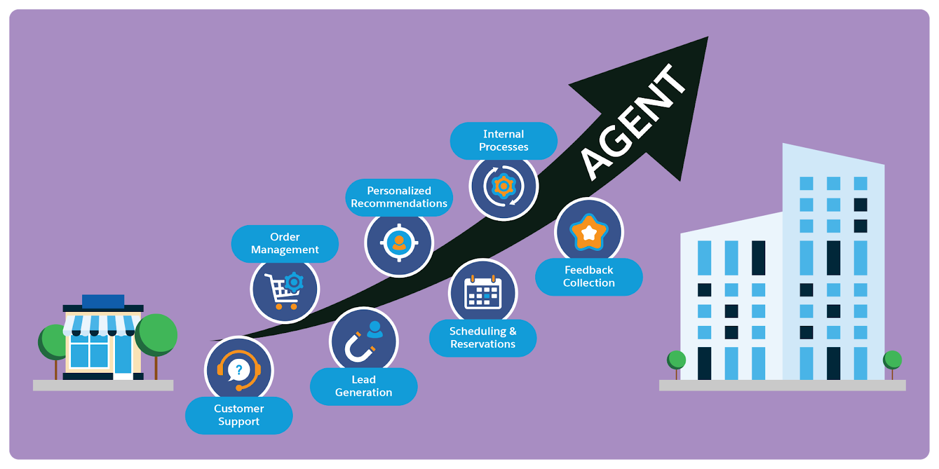
Meet Agentforce
Ready to give autonomous agents a try? At Salesforce, we’ve got just the thing for you. Our advanced conversational AI, Agentforce, is designed to boost productivity and lighten your team’s workload. These smart agents can handle routine tasks with ease and even lend a hand with more complex ones, all while operating independently within the parameters you set. They can be deployed across various customer channels to enhance engagement and efficiency.
The best part? Agentforce is seamlessly integrated into the Salesforce interface, making it a breeze to set up and launch agents right within your workflow. Imagine your team getting business tasks done with the help of a super-smart assistant, right where they work. Agents can also be deployed in your company's support channels to give your customers the same level of awesome assistance. Whether it’s your employees or your customers, Agentforce is there to make everyone's life easier and more efficient.
Trusted and Secure
Agentforce ensures that your data remains secure and private. The Einstein Trust Layer uses a secure gateway and zero-retention agreements to protect your company data. Additionally, it includes toxicity detection and audit trail logging to ensure that the agents’ responses are safe and compliant.
Powerful and Versatile
Agentforce uses industry-leading Salesforce applications to deliver transformative experiences across sales, service, commerce, marketing, and industries. By combining the language and reasoning capabilities of large language models (LLMs) with granular actions, these agents can handle a wide range of tasks and provide personalized experiences at scale.
Grounded in Unified Data
To deliver accurate and relevant outcomes, Agentforce is grounded in Salesforce data and unified data from Data 360. This ensures that these agents have access to the most up-to-date and relevant information, leading to better decision-making and more effective actions.
Agentforce is the perfect solution for integrating autonomous agents into your Salesforce Platform. With a comprehensive suite of tools, you can get up and running quickly and start improving your business processes faster than ever before. Experience the power of automation and watch your business thrive!
A Beginner’s Roadmap to Integrating Salesforce Autonomous Agents
Getting started with autonomous agents can seem daunting, but it’s‌ quite simple once you know what you want to achieve. Here are some helpful tips to keep in mind when you start the process.
Think Big, Start Smart: Plan Your Strategy
Define the goals and scope of your autonomous agents, and pinpoint the areas where they can make the biggest impact. For example, a retail company sees that a lot of customer service inquiries are about order tracking and returns. It decides to use Agentforce to automate these tasks. They want an autonomous agent to handle text-based interactions on the company’s website and mobile app, pulling customer order data from the CRM to provide real-time updates.
Design with Flair: Build Your Agent
Design and configure your autonomous agents to perform specific tasks and interactions. Using Agentforce to create the autonomous agent, the customer service team at the retail company creates a topic called Order Management that includes actions such as Check Order Status, Initiate Return, and Provide Tracking Information. They design the agent to handle these tasks autonomously, using natural language processing (NLP) to understand and respond to customer inquiries.
Put It to the Test: Test Your Agent
Conduct thorough testing to ensure your agent performs as expected, and resolve any issues before deploying it. The team’s customer service manager sets up a testing phase for their new agent. They simulate common customer inquiries and edge cases to make sure the agent can handle them like a pro. They collect user feedback through a survey and use this data to fine-tune the agent’s responses and actions. During testing, they see that the agent struggles with handling return requests, so the manager adjusts the instructions for the Initiate Return action and quickly resolves the issue.
Go Live and Celebrate: Launch Your Agent
After deploying the agent, the team monitors its performance and notices a significant reduction in the time it takes to resolve order tracking and return requests. They share this success with leadership and stakeholders, highlighting the efficiency gains and improved customer satisfaction. This success story helps build confidence and encourages further investment in time-saving autonomous agents. It’s like watching your agent ace its first big challenge and earn a gold star!
Wrap It Up
You’ve learned that effectively integrating autonomous agents into your workflow can save you significant time and resources while dramatically improving the overall customer experience. These smart agents are your secret weapon for boosting efficiency, allowing you to focus on other important tasks that propel your business forward.
Ready to transform your business with Agentforce? Start your journey today and see the difference for yourself.
Resources
- Trailhead: AI Strategy
- Trailhead: Agentforce: Quick Look
- Trailhead: AI + Data: Project Planning
- Trailhead: The Einstein Trust Layer
- Trailhead: Agentforce: Agent Planning
- Salesforce Help: AI Project Success
- Salesforce Help: Design and Implement Agents

Reasoning in Artificial Intelligence

Get to Know Reasoning Engines
Learning Objectives
After completing this unit, you’ll be able to:
- Describe what a reasoning engine is.
- List three types of reasoning that reasoning engines use to solve problems.
- List four popular reasoning strategies that guide LLMs.
AI’s Latest Innovation
AI can now do more than just chat. It can actually think through problems, weigh options, and make decisions. To do that–make complex decisions, deliver insights, and respond to the context of the moment–AI agents use reasoning.
But AI works best when you understand how it thinks. In this module, you explore how reasoning engines help advanced AI understand and deliver what you want–whether that’s drafting an email, generating a campaign brief, building a web page, researching competitors, analyzing data, summarizing a call, or another time-saving task.
So, what, exactly, is a reasoning engine?
A Reason to Rely on AI
A reasoning engine is a type of AI that gathers information, follows logical rules, and makes decisions–just like people do when solving problems.
And, like people, these engines typically use three types of reasoning.
- Deduction: “All fruits have seeds. A mango is a fruit. Therefore, a mango has seeds.” (Starts with a general rule and applies it to a specific case.)
- Induction: “The last five meetings started late. So, the next one will probably start late too.” (Looks at patterns in past experience to make a general prediction.)
- Abduction: “The lights are off and no one's answering the door—so they’re probably not home.” (Takes the best guess based on limited clues.)
These approaches make reasoning engines particularly useful. Their reasoning helps AI quickly solve problems that would normally require a thinking human’s perspective and awareness of context, allowing new ways of working at scale.
How LLMs Learn to Reason
Large language models (LLMs) became mainstream in late 2022, but researchers have been experimenting with ways to make them think and plan like humans. The secret? Prompts–carefully written instructions that guide the LLM’s response. When a prompt helps an LLM lay out a logical plan to solve a problem, we call that a reasoning strategy.
Here are four popular strategies.
1. Chain-of-Thought (CoT)
Think of this as teaching the LLM to “show its work.” CoT breaks a tough problem into a series of smaller steps, like a human working through a puzzle. It’s great for math word problems, common-sense reasoning, and other tasks that require logic. Bonus: Engineers can trace each step to see where things might have gone wrong.
2. Reasoning and Acting (ReAct)
ReAct combines reasoning with real-world actions. This strategy doesn’t just rely on what the LLM knows–it interacts, checks information, and refines its answers step by step with user feedback. This leads to fewer “hallucinations” (or wrong answers) and more trustworthy results.
3. Tree of Thoughts (ToT)
Instead of following one single plan, ToT explores many possible paths at each step, like brainstorming multiple options before choosing the best one. This makes ToT powerful for complex challenges like math puzzles, creative writing, or strategic decision-making.
4. Reasoning via Planning (RAP)
RAP takes reasoning a step further by helping the LLM simulate future outcomes. It predicts how actions will play out, explores alternatives, and refines its plan as it goes, much like a human strategist. RAP shines at tasks requiring long-term planning, logical inference, or multi-step problem-solving.
These strategies give LLMs a way to think through problems systematically, rather than just guessing. Whether breaking problems into steps (CoT), interacting with feedback (ReAct), exploring multiple options (ToT), or simulating future states (RAP), each approach makes AI feel a little more like human reasoning–only faster!
How Agentforce Deploys LLM Reasoning
Agentforce is Salesforce’s agentic layer, or smart AI helper. As a complete AI solution, it offers employees and customers a number of ways to chat with agents in plain language, helping teams work faster and customers get answers instantly. Behind the scenes, it uses large language models (LLMs) not just to understand and respond, but also to plan out complex tasks, like a reasoning engine.
Here’s what happens step by step.
- A user types in a request, for example,“Build a webpage.”
- Agentforce sends that input to a secure LLM using a carefully designed prompt. This helps the LLM translate the user’s input into a defined need that the AI understands.
- Once the intent is clear, another prompt asks the LLM to create a plan to get it done.
- The LLM responds with a step-by-step plan. This plan is built only from actions that an agent is allowed to take, ensuring safe and trusted behavior.
- The agent follows the steps, executes the actions in the right order, and delivers the result back to the user.
This process reduces the mental effort required from users. Instead of needing to figure out how to do something, a user can just say what they need—and Agentforce takes care of the how.
Reasoning in Action
Agentforce gives companies a bold new capability: It turns large language models into real-time reasoning engines. That means AI isn’t just answering questions, it’s making sense of complex scenarios, planning next steps, and taking action.
Here are a few examples of what that can look like.
- Sales feeling sluggish? Agentforce can scan your CRM, spot promising leads, and tee them up for your reps.
- Deals on the downswing? Agents can flag at-risk opportunities, summarize account histories, and equip managers with quick, clear insights.
- Overbilling issue? An agent pulls the right records, surfaces helpful troubleshooting steps, and helps resolve the issue quickly.
- Need to close the quarter strong? Agents can assess customer sentiment, predict deal trajectory, and recommend what to do today to set yourself up for success tomorrow.
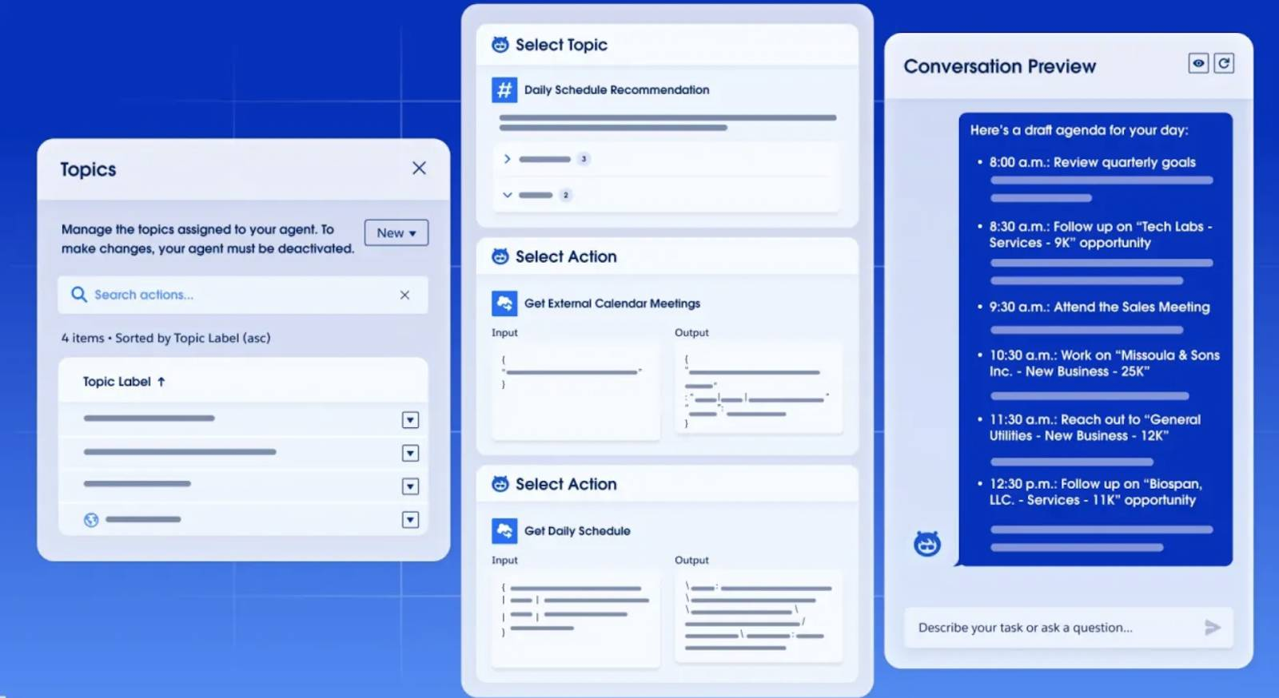
In all these examples, Agentforce acts like a semi-autonomous teammate. It’s thinking through problems with LLM-powered logic, responding to natural language, and driving connections between stakeholders.
Let’s Recap
Now that you understand the basics of reasoning engines, it’s easy to see why so many businesses are invested in the technology. Thanks to a human-like way of approaching real-world problems, AI can now stand shoulder-to-server with hardworking teams of professionals and deliver trusted, efficient, and easy solutions to meet your business objectives.
Next, explore the Salesforce reasoning engine, Atlas.

Discover the Atlas Reasoning Engine
Learning Objectives
After completing this unit, you’ll be able to:
- List 4 key concepts that the Atlas Reasoning Engine employs to improve AI.
- Describe 3 key capabilities of the Atlas Reasoning Engine.
Meet Atlas
The Atlas Reasoning Engine is the “brain” behind Agentforce, the agentic layer of the Salesforce Platform. Built on a proprietary system designed to simulate how humans think and plan, it uses multiple techniques, including advanced retrieval augmentation generation (RAG), to analyze information and determine the next-best actions for completing simple or complex‌ tasks. Like other reasoning engines, it ensures that AI agents can not only follow instructions, but also think proactively about the best way to translate those instructions into accomplishable goals.
How Does It Work?
To deliver reliable assistance, Atlas relies on a few key concepts.
- Reason–act–observe Loop (ReAct): Atlas uses a cycle of reasoning, acting, and observing. It thinks through a step, takes action, checks the outcome, and loops until it completes the user’s goal. If needed, it even asks for clarification mid-task. This keeps conversations natural and accurate.
- Topic classification: Every request is mapped to a topic, which serves as the AI’s job description for that moment. Topics define what actions are valid and which policies apply. This helps Atlas scale safely across thousands of scenarios.
- Richer conversations: Unlike earlier bots, Atlas allows Agentforce to respond in natural language, handle follow-up questions, and pull from past conversational context. The result? A smoother, more human-like interaction.
- Visible reasoning: Atlas shares its "thoughts"–the reasoning behind why it acted a certain way–so that admins can review decisions, prevent errors, and build trust. You can access those insights in Agent Builder.
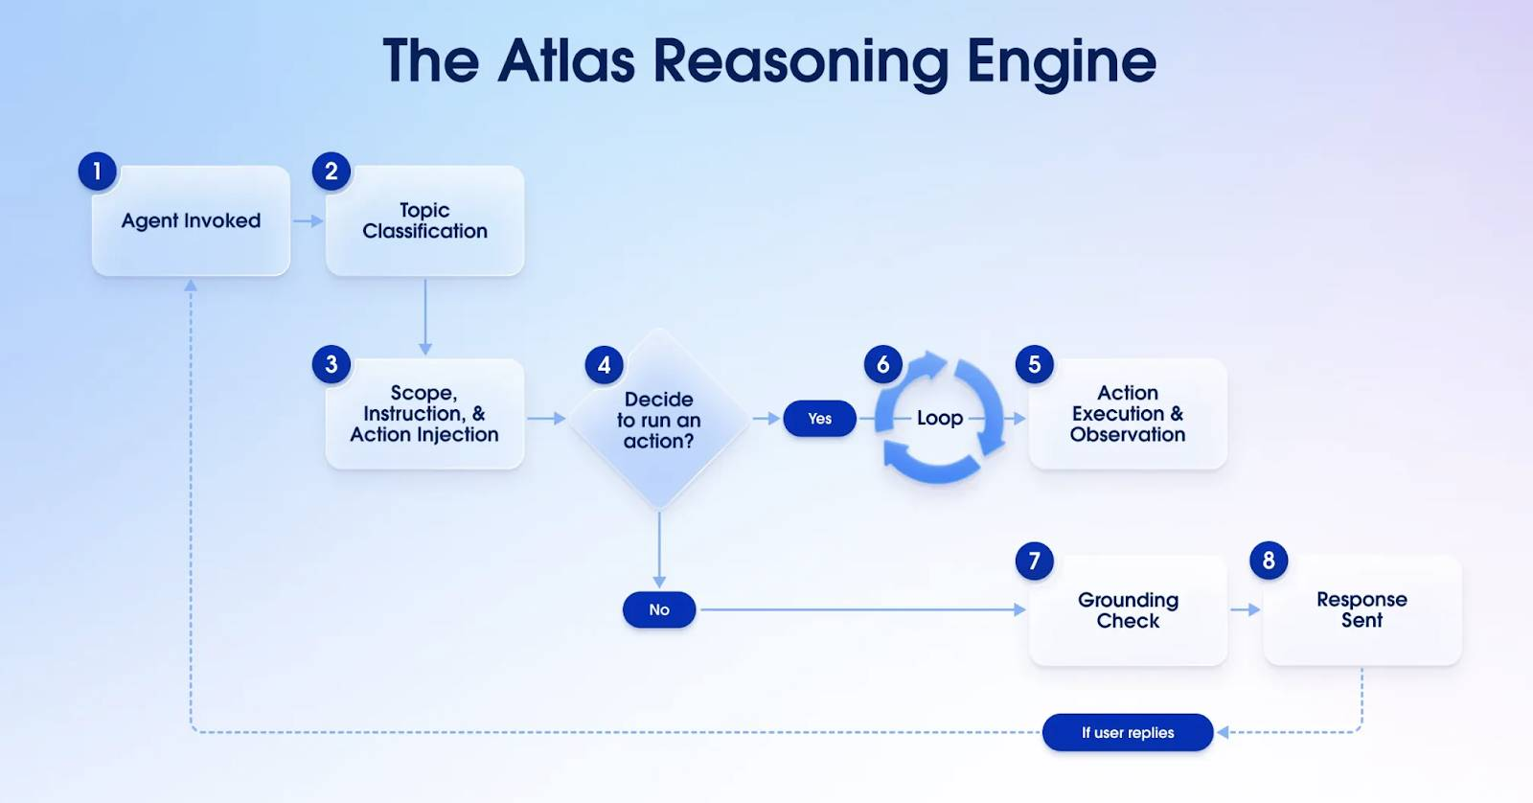
What Sets Atlas Apart?
So, what makes Atlas such a powerful part of Agentforce? Atlas is designed to value the things that empower and enable users all the way through an experience.
- Proactive actions: Agents don’t wait for you; they can trigger actions when CRM data changes, or an email arrives, or a meeting is upcoming.
- Dynamic information retrieval: Atlas pulls in the most relevant data–both structured and unstructured–from Salesforce Data 360, web searches, or internal docs. That means more accurate responses and richer actions from AI agents.
- Seamless human handoff: If Atlas hits a tough question or a strict business rule, it smoothly hands the conversation to a real human, so there's no drop in customer experience.
The Atlas Reasoning Engine transforms AI from reactive to reasoning. It listens, thinks, decides, and acts with purpose. It retrieves smart data, adapts to changes, involves users when needed, and explains its choices. Atlas makes AI capable, trustworthy, and truly helpful, so you can scale your teams with intelligence that feels effortless and human. The result? Humans partnered with AI agents can work faster and smarter at scale.
Because Atlas is goal-oriented, it doesn’t just respond, it drives toward successful outcomes, even if the path isn’t linear. This makes it ideal for handling real-world business scenarios where follow-ups, clarifications, or exceptions are the norm. With Atlas, your agents do more than chat: they collaborate, solve, and deliver results.
Resources
- Salesforce: How the Atlas Reasoning Engine Powers Agentforce
Advanced Retrieval Augmentation Generation (RAG) is a framework used to enhance the capabilities of large language models (LLMs) by grounding their responses with accurate, domain-specific information. Here's how it works:
- Retrieve: Relevant information is pulled from a knowledge store containing structured and unstructured content, such as documents, emails, or knowledge articles.
- Augment: This retrieved information is combined with the original prompt to provide context.
- Generate: The LLM uses the augmented prompt to generate a response that is more accurate and relevant.
This approach ensures that AI systems, like the Atlas Reasoning Engine in Salesforce, can provide informed, context-aware, and trustworthy responses. It’s particularly effective for handling complex queries and delivering data-driven answers.
For more details, check out these resources:
- Augment Agents and Prompts with Relevant Business Knowledge
- Optimize Hybrid Search Results for RAG

The Agent force Trust Layer

Meet the Agentforce Trust Layer
Learning Objectives
After completing this unit, you’ll be able to:
- Discuss the #1 Salesforce value, Trust.
- Describe concerns related to trust and generative AI.
- Explain why Salesforce created the Einstein Trust Layer.
Trailcast
If you'd like to listen to an audio recording of this module, please use the player below. When you’re finished listening to this recording, remember to come back to each unit, check out the resources, and complete the associated assessments.

This module addresses some future functionality of the Einstein Trust Layer. Any unreleased services or features referenced here are not currently available and may not be delivered on time or at all. Customers should make their purchase decisions based upon features that are currently available.
Before You Begin
We know you’re eager to learn how Salesforce protects your company and customer data as we roll out new generative artificial intelligence (AI) tools. But, before you begin, you should be familiar with the concepts and terminology covered in these badges.
- Generative AI Basics
- Natural Language Processing Basics
- Large Language Models
- Prompt Fundamentals
The Agentforce Glossary of Terms also covers many of the terms used in this badge, such as LLMs, prompts, grounding, hallucinations, toxic language, and more.
Generative AI, Salesforce, and Trust
Everyone is excited about generative AI because it unleashes their creativity in whole new ways. Working with generative AI can be really fun—for instance, using Midjourney to create images of your pets as superheroes or using ChatGPT to create a poem written by a pirate. Companies are excited about generative AI because of the productivity gains. According to Salesforce research, employees estimate that generative AI will save them an average of 5 hours per week. For full-time employees, that adds up to a whole month per year!
But for all this excitement, you probably have questions, like:
- How do I take advantage of generative AI tools and keep my data and my customers’ data safe?
- How do I know what data different generative AI providers are collecting and how it will be used?
- How can I be sure that I’m not accidentally handing over personal or company data to train AI models?
- How do I verify that AI-generated responses are accurate, unbiased, and trustworthy?
Salesforce and Trust
At Salesforce, we’ve been asking the same questions about artificial intelligence and security. In fact, we’ve been all-in on AI for almost a decade. In 2016, we launched the Einstein platform, bringing predictive AI to our clouds. Shortly thereafter, in 2018, we started investing in large language models (LLMs).
We’ve been hard at work building generative AI solutions to help customers use their data more efficiently and help make companies, employees, and customers more productive and efficient. And because Trust is our #1 value, we believe it’s not enough to deliver only the technological capabilities of generative AI. We believe we have a duty to be responsible, accountable, transparent, empowering, and inclusive. That’s why, as Salesforce builds generative AI tools, we carry our value of Trust right along with us.
Enter the Einstein Trust Layer. We built the Trust Layer to help you and your colleagues use generative AI at your organization safely and securely. Let’s take a look at what Salesforce is doing to make its generative AI the most secure in the industry.
What Is the Einstein Trust Layer?
The Einstein Trust Layer elevates the security of generative AI through data and privacy controls that are seamlessly integrated into the end-user experience. These controls enable Einstein to deliver AI that’s securely grounded in your customer and company data, without introducing potential security risks. In its simplest form, the Trust Layer is a sequence of gateways and retrieval mechanisms that together enable trusted and open generative AI.
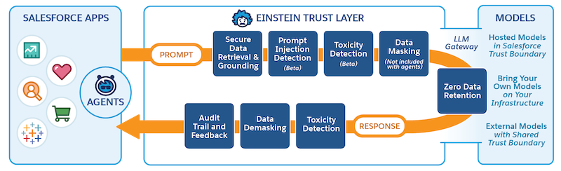
The Einstein Trust Layer lets customers get the benefit of generative AI without compromising their data security and privacy controls. It includes a toolbox of features that protect your data—like secure data retrieval, dynamic grounding, data masking, and zero data retention—so you don’t have to worry about where your data might end up. Toxic language detection scans prompts and responses for accuracy and to assure they are appropriate. And for additional accountability, an audit trail tracks a prompt through each step of its journey. You learn more about each of these features in the next units.
Data masking for LLMs is currently disabled for agents. For embedded generative AI features, such as Einstein Service Replies, Einstein Work Summaries data masking is available, and you can configure it in Einstein Trust Layer setup.
We designed our open model ecosystem so you have secure access to many large language models (LLMs), both inside and outside of Salesforce. The Trust Layer sits between an LLM and your employees and customers to keep your data safe while you use generative AI for all your business use cases, including sales emails, work summaries, and service replies in your contact center.
In the next units, dive into the prompt and response journeys to learn how the Einstein Trust Layer protects your data.
Resources
- Documentation: Einstein Generative AI Glossary of Terms
- Blog: Meet Salesforce’s Trusted AI Principles
- Blog: Generative AI: 5 Guidelines for Responsible Development
- Trailhead: Responsible Creation of Artificial Intelligence
- Trailhead: Generative AI Basics
- Trailhead: Natural Language Processing
- Trailhead: Large Language Models
- Trailhead: Prompt Fundamentals

Follow the Prompt Journey
Learning Objectives
After completing this unit, you’ll be able to:
- Explain how the trust layer securely handles your data.
- Describe how dynamic grounding improves a prompt's context.
- Describe how the Trust Layer's guardrails defend your data.
Trailcast
If you'd like to listen to an audio recording of this module, please use the player below. When you’re finished listening to this recording, remember to come back to each unit, check out the resources, and complete the associated assessments.
The Prompt Journey
You just learned a little bit about what the Trust Layer is, so let's look at how it fits into the bigger picture of generative AI at Salesforce. In this unit, you learn how a prompt moves through the Einstein Trust Layer on its way to the LLM.

This unit addresses some future functionality of the Einstein Trust Layer. Any unreleased services or features referenced here are not currently available and may not be delivered on time or at all. Customers should make their purchase decisions based upon features that are currently available.
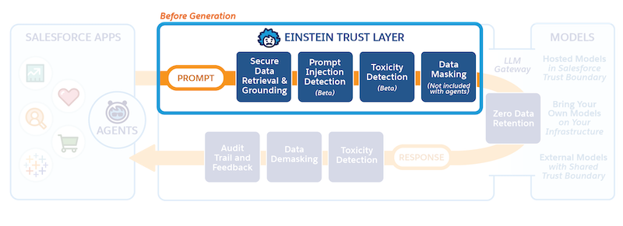
Prompt defense is available in Prompt Builder, Prompt Template Connect API, and the Prompt Template Invocable Action.
The Power of Prompts
In the Prompt Fundamentals Trailhead module, you learn that prompts are what power generative AI applications. You also learn that clear instructions, contextual information, and constraints help create a great prompt, which leads to a great response from the LLM. To make this easy and consistent for our customers, we pre-built prompt templates for all sorts of business use cases, like sales emails or customer service replies. When a request to the Trust Layer is made from any of our Salesforce apps, a relevant prompt template is called by the Trust Layer.
Let’s walk through a customer service case to illustrate the prompt journey. You’ll see the prompt template, how the template becomes populated with customer data and relevant resources, and ways the Einstein Trust Layer protects data before it moves to an external LLM to generate a response that’s relevant to the prompt.
Meet Jessica
Jessica is a customer service agent at a consumer credit card company. Her company has just implemented Service Replies, an Einstein-powered feature that generates suggested replies to customer agents during their chats with their customers. Jessica agreed to be one of the first agents to try it out. She’s known for her personal touch when working with customers, so she’s a little nervous that AI-generated replies might not match her style. But she’s eager to add some generative AI experience to her resume and curious to see if Service Replies could help her help more customers.
Jessica starts chatting with her first customer of the day, who wants help to upgrade his credit card. Service Replies begins suggesting replies right in the Service Console. The replies are refreshed each time the customer sends a new message, so they make sense in the context of the conversation. They’re also personalized to the customer, based on customer data stored in Salesforce. Each suggested reply is built from a prompt template. A prompt template contains instructions and placeholders that will be filled with business data—in this case, the data related to Jessica’s customer and their support case, and relevant data and flows from Jessica’s org. The prompt template is behind the Salesforce Trust Layer and Jessica, as an end user in the Service Console, can’t see prompt templates.
Let’s take a closer look at how this data moves through the trust layer to deliver relevant, high-quality replies while keeping customer data safe and secure.
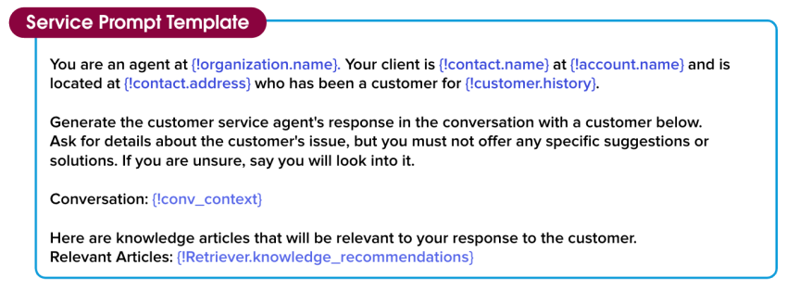
You are an agent at {!organization.name}. Your client is {!contact.name} at {!account.name} and is located at {!contact.address} who has been a customer for {!customer.history}.
Generate the customer service agent’s response in the conversation with a customer below. Ask for details about the customer’s issue, but you must not offer any specific suggestions or solutions. If you are unsure, say you will look into it.
Conversation: {!conv_context}
Here are the knowledge articles that will be relevant to your response to the customer.
Relevant Articles: {!Retriever.knowledge_recommendations}
Dynamic Grounding
Relevant, high-quality responses require relevant, high-quality input data. When Jessica’s customer enters the conversation, Service Replies links the conversation to a prompt template and begins replacing the placeholder fields with page context, merge fields, and relevant knowledge articles from the customer record. This process is called dynamic grounding. In general, the more grounded a prompt is, the more accurate and relevant the response will be. Dynamic grounding is what makes prompt templates reusable so they can be scaled across an entire organization.
The process of dynamic grounding starts with secure data retrieval, which identifies relevant data about Jessica’s customer from her org. Most importantly, secure data retrieval respects all of the Salesforce permissions currently in place in her org that limit access to certain data on objects, fields, and more. This ensures that Jessica is only pulling information that she’s authorized to access. The data that is retrieved doesn’t contain any private information, or anything that requires escalated permissions.

Dynamic grounding pulls data from your org, so it’s important to make sure your data is kept current, accurate, and complete. Visit the Data Quality Trailhead module to learn how to keep your data healthy.
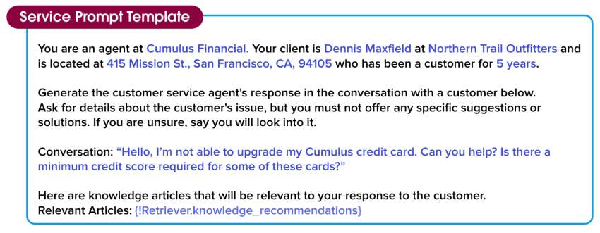
You are an agent at Cumulus Financial. Your client is Dennis Maxfield at Northern Trail Outfitters and is located at 415 Mission St., San Francisco, CA, 94105 who has been a customer for 5 years.
Generate the customer service agent’s response in the conversation with a customer below. Ask for details about the customer’s issue, but you must not offer any specific suggestions or solutions. If you are unsure, say you will look into it.
Conversation: “Hello, I’m not able to upgrade my Cumulus credit card. Can you help? Is there a minimum credit score required for some of these cards?”
Here are the knowledge articles that will be relevant to your response to the customer.
Relevant Articles: {!Retriever.knowledge_recommendations}
Semantic Search
In Jessica’s case, customer data is enough to personalize the conversation. But it’s not enough to help Jessica quickly and effectively solve the customer’s problem. Jessica needs information from other data sources like knowledge articles and customer history to answer questions and identify solutions. Semantic search uses machine learning and search methods to find relevant information in other data sources that can be automatically included in the prompt. This means that Jessica doesn’t have to search for these sources manually, saving her time and effort.
Here, semantic search found a relevant knowledge article to help solve the credit card issue and included the relevant chunk of the article in the prompt template. Now this prompt is really taking shape!
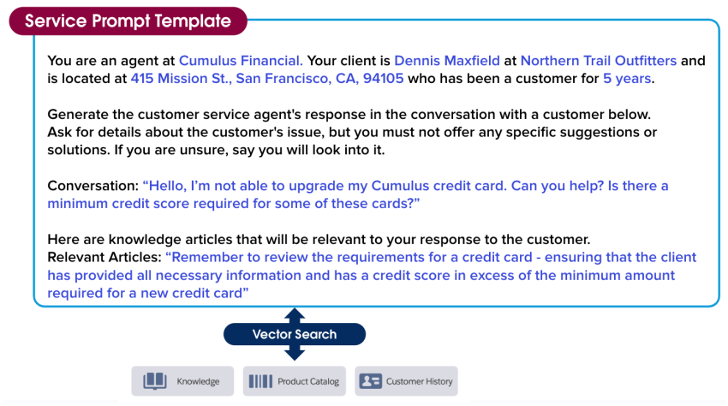
You are an agent at Cumulus Financial. Your client is Dennis Maxfield at Northern Trail Outfitters and is located at 415 Mission St., San Francisco, CA 94105 who has been a customer for 5 years.
Generate the customer service agent’s response in the conversation with a customer below. Ask for details about the customer’s issue, but you must not offer any specific suggestions or solutions. If you are unsure, say you will look into it.
Conversation: “Hello, I’m not able to upgrade my Cumulus credit card. Can you help? Is there a minimum credit score required for some of these cards?”
Here are the knowledge articles that will be relevant to your response to the customer.
Relevant Articles: “Remember to review the requirements for a credit card - ensuring that the client has provided all the necessary information and has a credit score in excess of the minimum amount required for a new credit card”
Data Masking
Although the prompt contains accurate data about Jessica’s customer and their issue, it’s not yet ready to go to the LLM because it contains information like client and customer names and addresses. The Trust Layer adds another level of protection to Jessica’s customer data through data masking. Data masking involves tokenizing each value, so that each value is replaced with a placeholder based on what it represents. This means that the LLM can maintain the context of Jessica’s conversation with her customer and still generate a relevant response.
Salesforce uses a blend of pattern matching and advanced machine learning techniques to intelligently identify customer details like names and credit card information, then masks them. Data masking happens behind the scenes, so Jessica doesn’t have to do a thing to prevent her customer’s data from being exposed to the LLM. In the next unit, you learn about how this data is added back into the response.
Although Salesforce has zero data retention policy with the third-party LLMs, some companies and use cases or regulation policies may require sensitive data not to be sent to the LLM at all. Jessica reaches out to her Salesforce admin to make sure data masking is turned on so her customer sensitive data is not sent to the LLM.
Data masking for LLMs is currently disabled for agents. For embedded generative AI features, such as Einstein Service Replies, Einstein Work Summaries data masking is available, so Jessica is able to use this option for her use case.
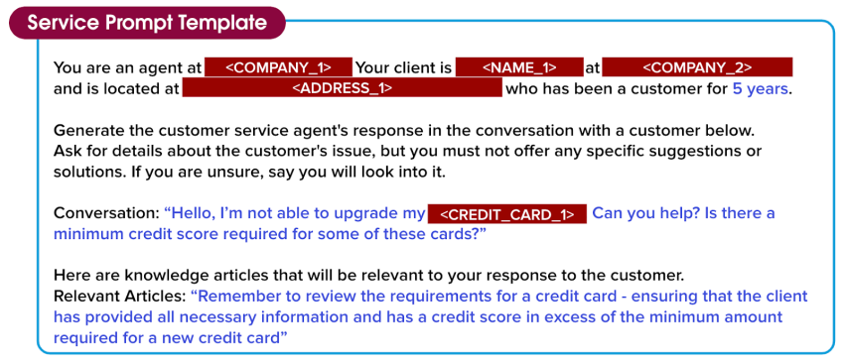
You are an agent at <COMPANY_1>. Your client is <NAME_1> at <COMPANY_2> and is located at <ADDRESS_1> who has been a customer for 5 years.
Generate the customer service agent’s response in the conversation with a customer below. Ask for details about the customer’s issue, but you must not offer any specific suggestions or solutions. If you are unsure, say you will look into it.
Conversation: “Hello, I’m not able to upgrade my <CREDIT_CARD_1>. Can you help? Is there a minimum credit score required for some of these cards?”
Here are the knowledge articles that will be relevant to your response to the customer.
Relevant Articles: “Remember to review the requirements for a credit card - ensuring that the client has provided all the necessary information and has a credit score in excess of the minimum amount required for a new credit card”
Prompt Defense
Prompt Builder provides additional guardrails to protect Jessica and her customers. These guardrails are further instructions to the LLM about how to behave in certain situations to decrease the likelihood it outputs something unintended or harmful. For example, an LLM might be instructed to not address content or generate answers that it doesn’t have information about.
Hackers, and sometimes even employees, are eager to get around restrictions and attempt to perform tasks or manipulate the model’s output in ways that the model wasn’t designed to handle. In generative AI, one of these types of attacks is called prompt injection. Prompt defense can help protect from these attacks and decrease the likelihood of data being compromised.
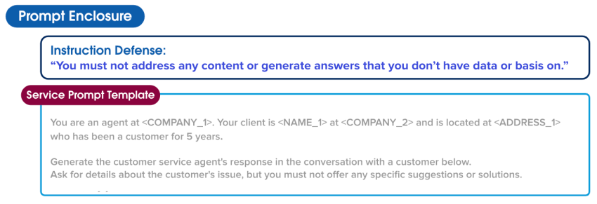
Instruction Defense: “You must not address any content or generate answers that you don’t have data or basis on.”
Next, let’s take a look at what happens to this prompt when it crosses the Secure Gateway into an LLM.
Resources
- Salesforce AI Research: Trusted AI
- Trailhead: Data Quality
- Trailhead: Prompt Builder Basics

Follow the Response Journey
Learning Objectives
After completing this unit, you’ll be able to:
- Describe the response journey.
- Explain zero data retention.
- Discuss why toxic language detection is important.
Trailcast
If you'd like to listen to an audio recording of this module, please use the player below. When you’re finished listening to this recording, remember to come back to each unit, check out the resources, and complete the associated assessments.

This unit addresses some future functionality of the Einstein Trust Layer. Any unreleased services or features referenced here are not currently available and may not be delivered on time or at all. Customers should make their purchase decisions based upon features that are currently available.
A Quick Prompt Journey Review
You can already see the careful steps Salesforce takes with the Einstein Trust Layer to protect Jessica’s customer data and their company data. Before you learn more, do a quick review of the prompt journey.
- A prompt template was automatically pulled in from Service Replies to assist with Jessica’s customer service case.
- The merge fields in the prompt template were populated with trusted, secure data from Jessica’s org.
- Relevant knowledge articles and details from other objects were retrieved and included to add more context to the prompt.
- Personally identifiable information (PII) was masked.
- Extra security guardrails were applied to the prompt to further protect it.
- Now the prompt is ready to pass through the secure gateway to the external LLM.
The Secure LLM Gateway
Populated with relevant data, with protective measures in place, the prompt is ready to leave the Salesforce Trust Boundary by passing through the Secure LLM Gateway to connected LLMs. In this case, the LLM Jessica’s org is connected to is OpenAI. OpenAI uses this prompt to generate a relevant, high-quality response for Jessica to use in her conversation with her customer.

The prompt may interact with the Trust Layer differently when interacting with LLMs that live inside the Salesforce Trust Boundary, such as Salesforce LLMs developed in-house.
Zero Data Retention
If Jessica was using a consumer-facing LLM tool, like a generative AI chatbot, without a robust trust layer, her prompt, including all of her customer’s data, and even the LLM’s response, could be stored by the LLM for model training. But when Salesforce partners with an external API-based LLM, we require an agreement to keep the entire interaction safe—it’s called zero data retention. Our zero data retention policy means that no customer data including the prompt text and generated responses are stored outside of Salesforce.
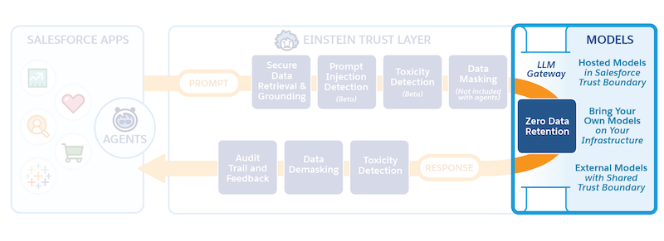
Here’s how it works. Jessica’s prompt is sent out to an LLM—remember, that prompt is an instruction. The LLM takes that prompt, and following its instructions while adhering to the guardrails, generates one or more responses.
Typically, OpenAI wants to retain prompts and prompt responses for a period of time to monitor for abuse. OpenAI’s incredibly powerful LLMs check to see if anything unusual is happening to their models—like the prompt injection attacks that you learned about in the last unit. But our zero data retention policy prevents the LLM partners from retaining any data from the interaction. We arrived at an agreement where we handle that moderation.
We don’t allow OpenAI to store anything. So when a prompt is sent to OpenAI, the model forgets the prompt and the responses as soon as the response is sent back to Salesforce. This is important because it allows Salesforce to handle its own content and abuse moderation. Additionally, users like Jessica don’t have to worry about LLM providers retaining and using their customers’ data.
The Response Journey
When we first introduced Jessica, we mentioned that she was a little nervous that AI-generated replies might not match her level of conscientiousness. She’s really not sure what to expect, but she doesn’t need to worry, because the Einstein Trust Layer has that covered. It contains several features that help keep the conversation personalized and professional.
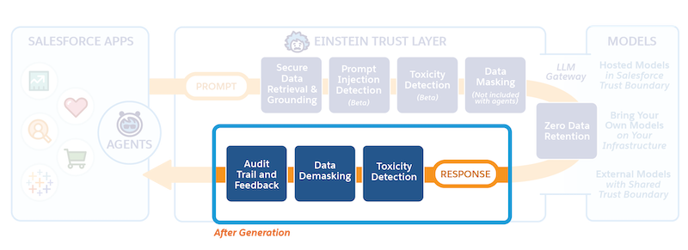
So far, we’ve seen the prompt template from Jessica’s conversation with her customer become populated with relevant customer information and helpful context related to the case. Now, the LLM has digested those details and delivered a response back into the Salesforce Trust Boundary. But it’s not quite ready for Jessica to see, yet. While the tone is friendly and the content accurate, it still needs to be checked by the Trust Layer for unintended output. The response also still contains blocks of masked data, and Jessica would think that’s much too impersonal to share with her customer. The Trust Layer still has a few more important actions to perform before it shares the response with her.
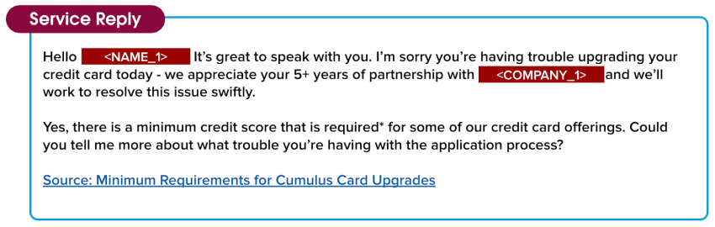
Hello <NAME_1>! It’s great to speak with you. I’m sorry you’re having trouble upgrading your credit card today - we appreciate your 5+ years of partnership with <COMPANY_1> and we’ll work to resolve this issue swiftly.
Yes, there is a minimum credit score that is required*for some of our credit card offerings. Could you tell me more about what trouble you’re having with the application process?
Source: Minimum Requirements for Cumulus Card Upgrades
Toxic Language Detection and Data Demasking
Two important things happen as the response to Jessica’s conversation passes back into the Salesforce Trust Boundary from the LLM. First, toxic language detection protects Jessica and her customers from toxicity. What’s that, you ask? The Trust Layer uses machine learning models to identify and flag toxic content in prompts and responses, in five categories: violence, sexual, profanity, hate, and physical. The overall toxicity score combines the scores from all detected categories and produces an overall score that ranges from 0 to 1, with 1 being the most toxic. The score for the initial response is returned along with the response to the application that called it—in this case, Service Replies.
Next, before the prompt is shared with Jessica, the Trust Layer needs to reveal the masked data we talked about earlier so that the response is personal and relevant to Jessica’s customer. The Trust Layer uses the same tokenized data we saved when we originally masked the data to demask it. Once the data is demasked, the response is shared with Jessica.
Also, notice that there is a Source link at the bottom of the response. Knowledge Article Creation adds credibility to responses by including links to contributing, helpful source articles.
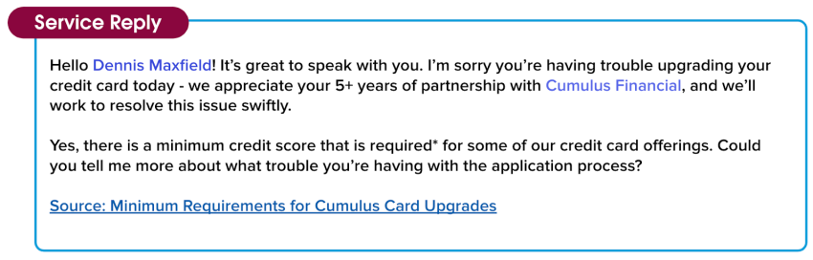
Hello Dennis Maxfield! It’s great to speak with you. I’m sorry you’re having trouble upgrading your credit card today - we appreciate your 5+ years of partnership with Cumulus Financial and we’ll work to resolve this issue swiftly.
Yes, there is a minimum credit score that is required* for some of our credit card offerings. Could you tell me more about what trouble you’re having with the application process?
Source: Minimum Requirements for Cumulus Card Upgrades
Feedback Framework
Now, seeing the response for the first time, Jessica smiles. She’s impressed with the quality and level of detail in the response she received from the LLM. She’s also pleased with how well it aligns with her personal case-handling style. As Jessica reviews the response before sending it to her customer, she sees that she can choose to accept it as is, edit it before sending it, or ignore it.
She can also (1) give qualitative feedback in the form of a thumbs up or thumbs down, and (2) if the response wasn’t helpful, specify a reason why. This feedback is collected, and in the future, it can be securely used to improve the quality of the prompts.
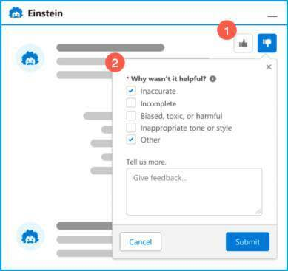
Audit Trail
There is one final piece of the Trust Layer to show you. Remember the zero data retention policy we talked about in the beginning of this unit? Since the Trust Layer is handling toxic language scoring and moderation internally, we keep track of every step that happens during the entire prompt-to-response journey.
Everything that has transpired during this entire interaction between Jessica and her customer is timestamped metadata that we collect into an audit trail. This includes the prompt, the original unfiltered response, any toxic language scores, and feedback collected along the way. The Einstein Trust Layer audit trail adds a level of accountability so Jessica can be sure her customer’s data is protected.
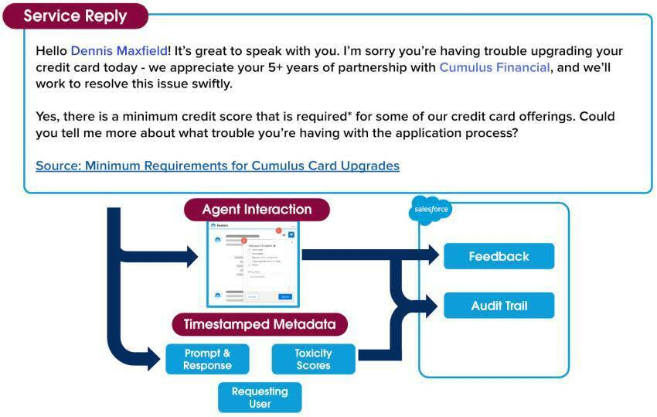
A lot has happened since Jessica started helping her customer, but it all happened within a blink of an eye. Within seconds, her conversation went from a prompt called by a chat, through the security of the entire Trust Layer process, to a relevant, professional response she can share with a customer.
She closes the case, knowing her customer is happy with the response and the customer service experience he received. And best of all, she’s excited to continue to use the generative AI power of Service Replies, because she feels confident that it will help her close her cases faster and delight her customers.
Every single one of the Salesforce generative AI solutions goes through the same Trust Layer journey. All of our solutions are safe, so you can be confident that your data and your customers data is secure.
Congratulations, you just learned how the Einstein Trust Layer works! To learn more about what Salesforce is doing around trust and generative AI, earn the Responsible Creation of Artificial Intelligence Trailhead badge.
Resources
- Trailhead: Responsible Creation of Artificial Intelligence
- Salesforce Help: Einstein GPT: Trusted Generative AI

